Bili Meter
Designed by Greg Nusz and Advait Kotecha
In Cooperation with Engineering World Health

Summary:
The objective of this construction manual is the production of a low-cost, easy to use, low-maintenance device for measuring the efficacy of phototherapy lights bili-lights for the treatment of hyperbilirubinemia (jaundice). The purpose of this device is to measure the output of phototherapy units and to ensure that the emitted light is intense enough (>4μW/cm²/nm) within the correct wavelength range (425 – 475nm).
The device operates by filtering the incident light through blue-glass filters. The light that passes through the filters is then collected by a solar cell where it generates a current that is read as the device’s output via an onboard ammeter. Because the measured current is generated by the incident light, no other power source is needed.

Parts List

34mm Blue Colored Glass Filter x 2 | Pegasus Associates Lighting | PCGF-MR11-BLU | 2 @ $5.90 = $11.80
0-1mA DC Ammeter | Marlin P. Jones & Assoc. | 8726 ME | $13.95
Solar Cell 0.5V, 300mA | Edmund Scientific | Item # 3081612 | $6.95
Box: HAMMOND — Multipurpose Instrument Enclosure  4.72” x 3.15” x 2.17” | Newark | Newark Part Number: 87F2528  Manufacturer Part No: 1591TSBK | $5.84
Fasteners |  |  | $0.20
 |  | Total | $38.74

Parts:
Filters- The blue glass filters from Pegasus Associates Lighting were selected because their transmission spectrum closely matches the absorption spectrum of bilirubin. Two were used to further diminish transmission of non-therapeutic light. Also, the 34mm round filters fit nicely with the solar cell selected. It would be possible to buy blue glass in bulk from an art supply company and cut the pieces necessary for use, although the transmission spectrum of the glass should be measured first. The following diagram shows the transmission spectrum of the dual-filter setup with the absorption spectrum of bilirubin overlaid.
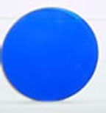
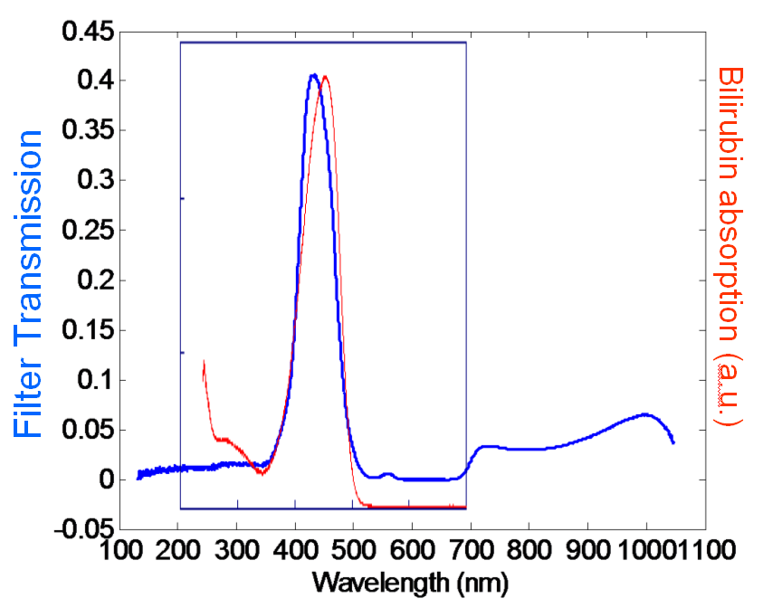

Ammeter – We selected the 0 -1 mA DC ammeter from MPJ because it offered high
precision measurements (+/- 2.5%) for the low currents generated by the solar cell.
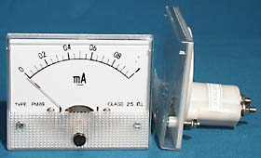

Solar Cell – Edmund Scientific offers several models of solar cell. The model we selected was chosen because of its relatively high current output for its size, the fact that the leads are already connected, and because of the casing that includes plastic lensing that allows for more efficient collection of light.
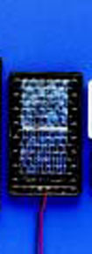
Box – The dimensions of the box selected are purely a function of the size of the solar cell and the ammeter.
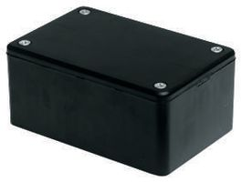

Fasteners: The only fasteners required for full assembly of the device are three nuts and three bolts (~1/8” diameter and at least ¾” long).

Building
Step 1: Cut big holes
- For the ammeter, cut a round 2-3/8” diameter centered on front.
- Two 1/8” holes for ammeter mounting screws 1-3/4” from center of the large hole and 2-17/32” from each other (See picture).
- Filter hole 1 ¾” diameter centered on the top.
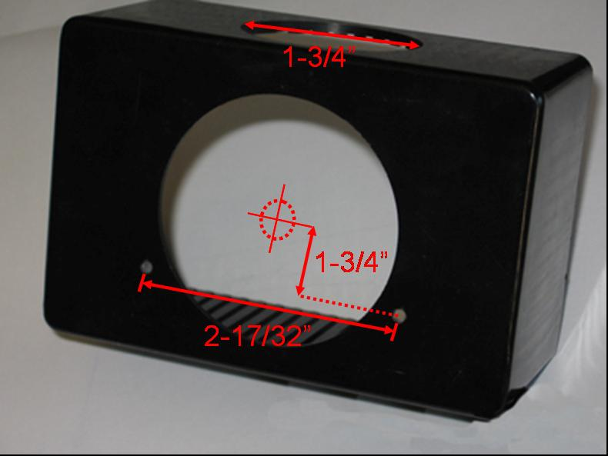

Step 2: Drill holes for filters and cell mounting screws
- First, drill three holes (~1/8” depending on bolts used) on the top so that the edges of the new holes are 1/8” from the edge of the filter hole (See picture). These holes are for bolts that should just touch the edge of the filter (see picture)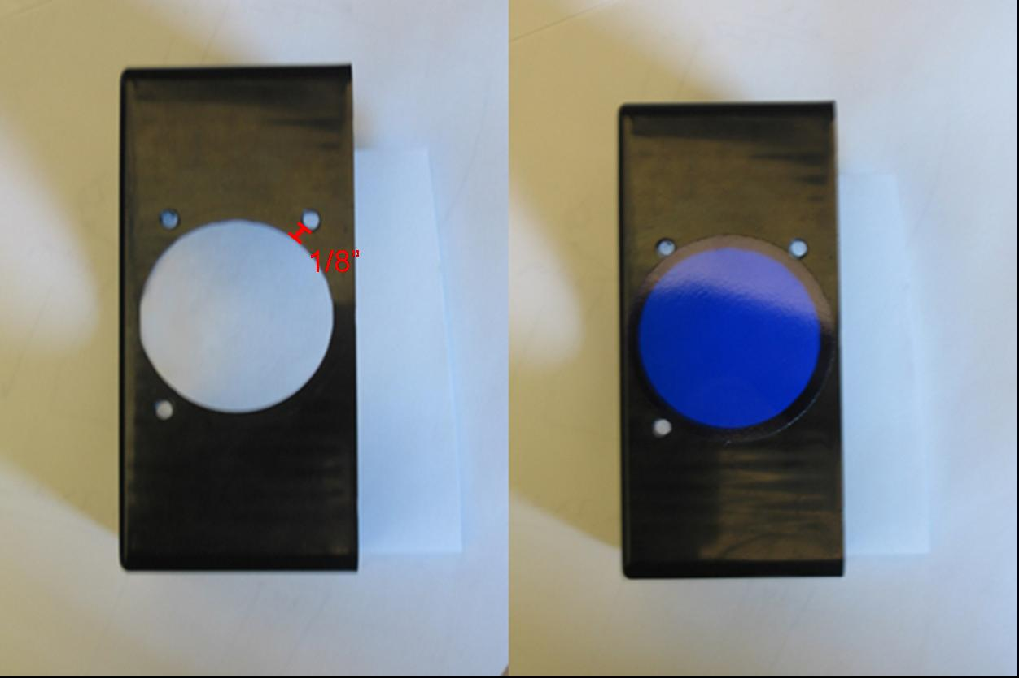

- Clamp solar cell to the box with the cell facing up out of the filter hole (See picture) and re-drill the same holes for the mounting holes through the casing of the cell. Be sure that the cell is in far enough so that the back will close. Also be careful not to damage the cell or wiring while drilling! It may also be necessary to remove any plastic bits from inside the cell casing if they aren’t drawn out while drilling.
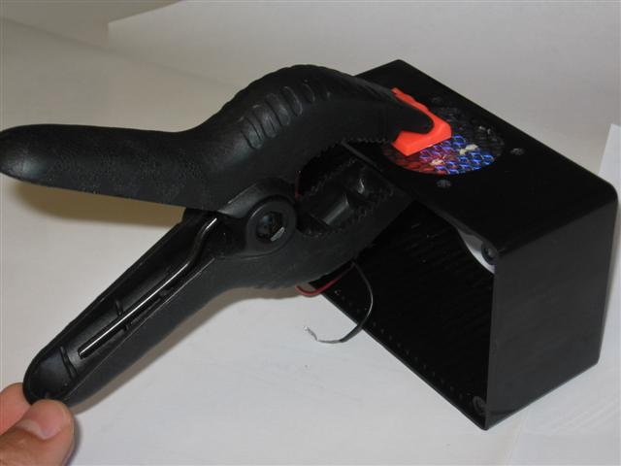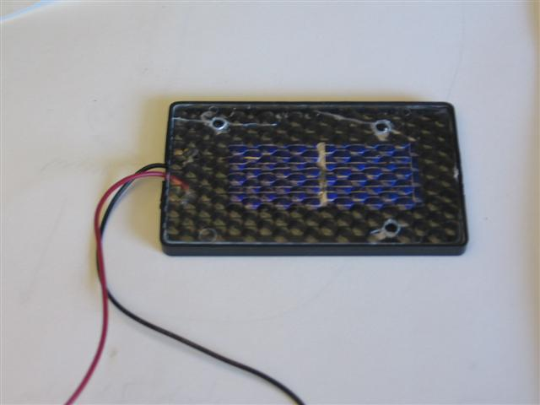

Step 3: Insert the mounting screws, through both the box and the solar cell so the heads are on the outside of the box. Put nuts on the bolts just below the cell, but do not tighten them.
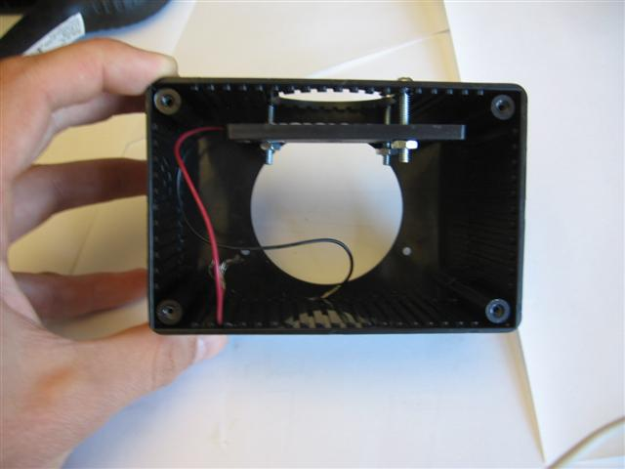

Step 4: Insert the filters between the cell and the box and tighten the nuts. Be careful not to crack the cell casing. Wipe the surface of the filters with a dry rag to remove any fingerprints – especially those surfaces that will be inaccessible after mounting.
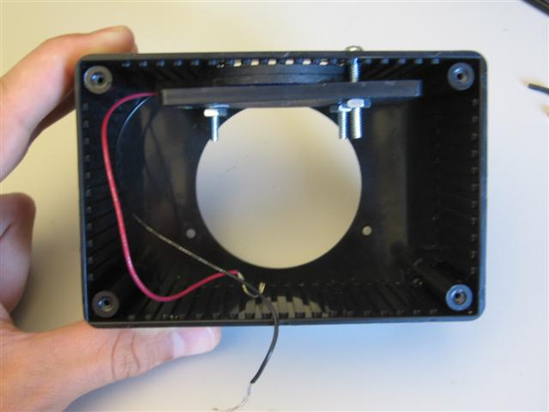

Step 5: Install ammeter by putting it through the holes in the box and attaching the two mounting nuts. Also connect the leads from the solar cell to the ammeter, attaching the black wire from the cell to the negative pole of the ammeter marked with a “-.”
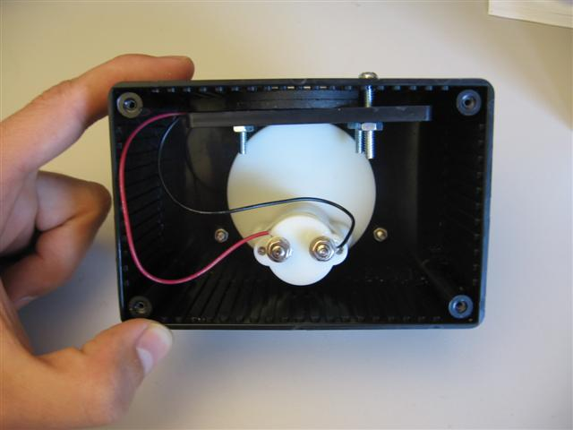

Step 6: Close the box by putting on the back panel.
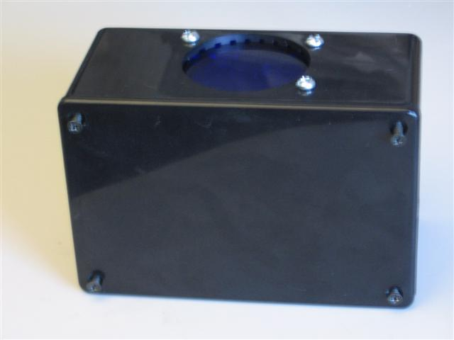

Step 6: Calibrate the Photometer.
For ease of use, we use the following ring image to provide a yes/no response from the radiometer. The idea is to put the green/red interface at the current level where enough blue light is available to be phototherapeutic (4 μW/cm^2/nm). This current will vary a bit from device to device and is best determined for each unit independently. Obviously, this requires some additional hardware. The units described here were calibrated using an Olympus Bili-meter. For the three units tested, calibration currents found were 0.12 mA, 0.18 mA and 0.14 mA. Any change in construction or components will alter this calibration current and as such, any radiometers modified from these directions must be independently calibrated.


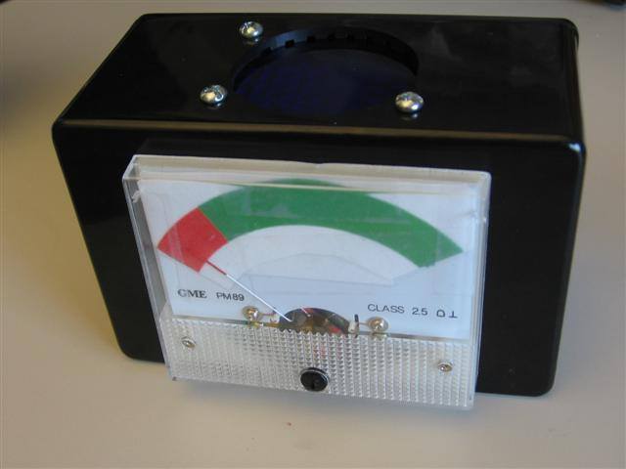

Limitations
The primary limitation for this device is related to the filter’s inability to completely block infrared (IR) light. Since silicon has a high responsivity even the 5% that passes through the filter can contribute to the signal and thus cause false positive readings in the presence of IR. For this reason, the radiometer will not provide accurate readings for incandescent bulbs are outdoors. However, most bililights in use are either fluorescent or LED-based. Any suggestions for low-cost solutions to this problem are welcome.
Directions for Use:
The meter should be held the same distance and direction from the bililight as the baby receiving treatment. The needle indicator in the red indicates that insufficient light is emitted by the light in the wavelength range 425-475nm, and the bulbs should be replaced. The needle indicator in the green indicates that there is sufficient blue light in the therapeutic window to treat hyperbilirubinemia. The final page of this document is an example directions-for-use sheet.
Bili-Light Tester Instructions

$\frac{4μW}{{\text{cm}}^{2}⋅\text{nm}}$
GOOD

$\frac{4μW}{{\text{cm}}^{2}⋅\text{nm}}$
BAD

