Bili-Light Tester Instructions

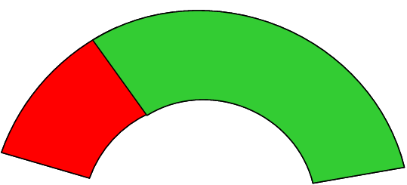$\frac{4μW}{{\text{cm}}^{2}⋅\text{nm}}$
GOOD

$\frac{4μW}{{\text{cm}}^{2}⋅\text{nm}}$
BAD

