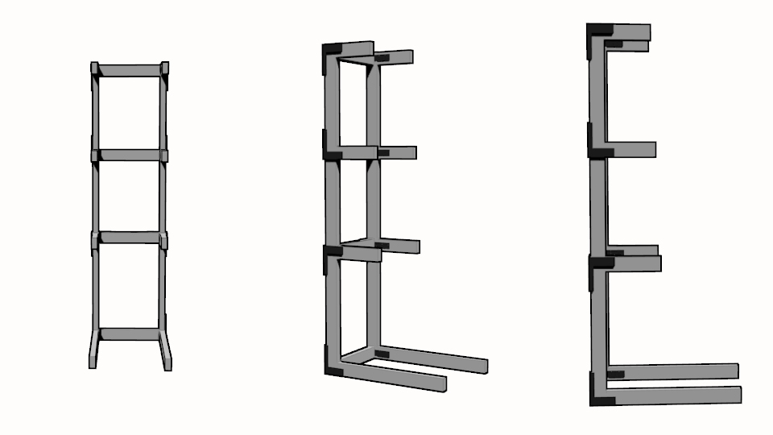
You need to make sure that you have all of the building material required as well as a cordless drill, means of cutting wood, tape measure and a pencil.

Once you have all those things you need to cut the two main support beams from the 10 foot boards at the length of 2.64 meters or 226.4 centimeters or 89.133 inches.

Next cut out 4, 50 cm lengths of one of the 8 foot boards

Then 2, 27 cm cuts, then 2, 30 cm cuts, then 2, 33 cm cuts, and then 2, cut’s for the base, mine was 90 centimeters.

Screw everything in then you’re done.

