Final Project Report

ON

Controlling Remote Robot With IOT and Motion Sensor

BY

Sultan Morbiwala 2015A4PS0367U Mechanial Engineering

AT

DUBAI, UAE



Project

BITS PILANI, DUBAI CAMPUS
Dubai International Academic City, Dubai
UAE

(JANUARY - MAY 2019)
BITS PILANI, DUBAI CAMPUS
Dubai International Academic City, Dubai
UAE
Centre: DUBAI

Duration: 20th Jan – 30th May, 2019 Date of Start: 20th Jan, 2019

Date of Submission: 15th May, 2019

Title of the Project:-

Controlling Remote Robot With IOT and Motion Sensor

ID No. / Name of the student: 2015A4PS0367U / Sultan Morbiwala

Discipline of Student: Mechanical Engineering

Name of the Faculty: Dr. Nilesh Goel

Key Words: IOT, Robotics, Motion Sensor, Mechatronics, Electronics, Mechanical Arm

Project Area(s): Mechatronics, Design, IOT

Abstract (Max 200 words):

Purpose of this project is to create a robot which can interact with physical environment anywhere around the world through WIFI. Using the motion sensor attached to hand and mobile app, full bot can be controlled by anyone. Teleoperation has various application in monitoring hazard environment and virtual travel for disabled people.

ACKNOWLEDGEMENTS

I would like to thank my university for give me this opportunity, expertise & resources required to implement this project. The innovation driven environment in BPDC is what motivated me to implement the idea of my own that would benefit humanity.
Mostly I am grateful of Dr Nilesh Goel who helps me to avoid many common pitfalls when I was learning about electronics. His advices are what helped me to accelerate progress in this project which would be difficult if I tried to do everything by myself.

Sultan Morbiwala
Mechanical Engineering

Contents

Chapter 1:- Introduction
  - Overview
  - Mechanical Design
  - Torque Calculation
  - Components Used
1.4.1 Software
1.4.1.1 Arduino IDE
1.4.1.2 MIT App Inventor
1.4.1.3 PubNub
1.4.2 Hardware
1.4.2.1 Node Mcu
1.4.2.2 MPU9250 IMU Sensor
      - Servo Motor
      - Hand Suction
      - 12V DC Motor
      - Raspberry Pi V3 and Pi camera
  - Electrical Circuit
  - Arduino Code
  - Conclusion

INTRODUCTION

Objective
To create a Robot which can interact with any physical environment without human presence.

Application:-
- Giving virtual locomotion to disabled people
- Monitoring Hazardous environment like mining, radioactivity, Nuclear plant
- Reducing travelling time and cost to manipulate the environment instead of being physically present there
Overview
The overall idea is to use mobile app to control locomotion of robot and mechanical arm on top base to interact with physical environment. Base motor will be DC motor and arm will be controlled by servo motor. All the communication will happen through node mcu and PubNub IOT platform.

This project has mechanical, electronics & software components. First comes the design, actuator to use, then comes the electronics programming, processor and in the end comes the IOT platform and mobile application.

Mechanical Design

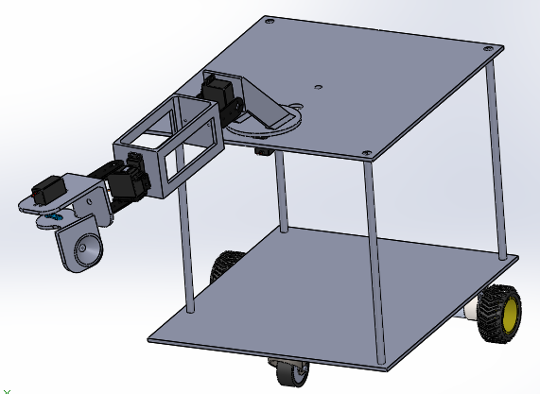
Design consist of 2 base so that all the electronics components can be fitted on 2 layers. Both the base is connected with a rod joined with nut and bolt. Bottom base will have 12V DC motor and one caster wheel to provide stable motion with minimum cost. Top base consists of mechanical arm which will be controlled by servo motor. Total height between base will be 30cm and total height of mechanical arm will be 50cm. Top base has a hole which will allow easy passing of wires to the components above.

For production, Mechanical arm parts will be 3D printed due to irregularity of shape while the bottom base will be made of wood since it has bigger size and simple design. Any modification on wood can be done using saw machine easily.

Torque Calculation
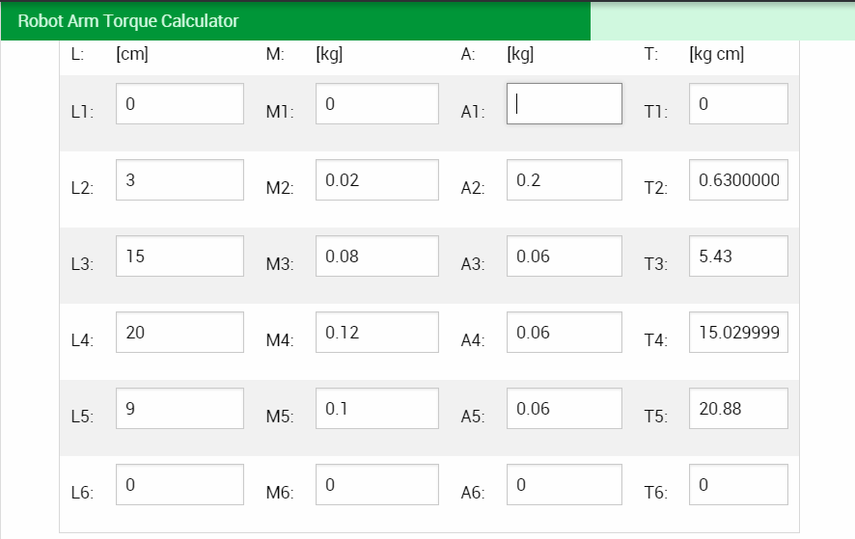

Above Calculation is done using online ‘robotic arm torque calculator’ on robotshop website. Using this calculation as reference, specs of motor and design of robot was decided. Servo motor placed on each point has higher torque compared to above torque.

Servo motor placement:-
S No. | Location | Servo used | Servo Torque (kg.cm) | Torque Req  (kg.cm)
1 | L5 | Jx servo | 32 | 20.88
2 | L4 | Kuman | 17 | 15
3 | L3 | MG995, Kuman | 17/10 | 5.4
4 | L2 | MG995 | 10 | 0.6

Specs of motor below:-
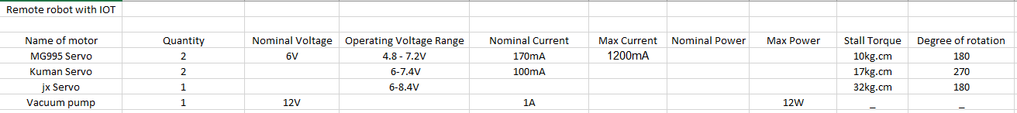

Actual Torque Calculation
As a precaution, not everything can be trusted on internet or software so I decided to double check the reading by calculating manually.
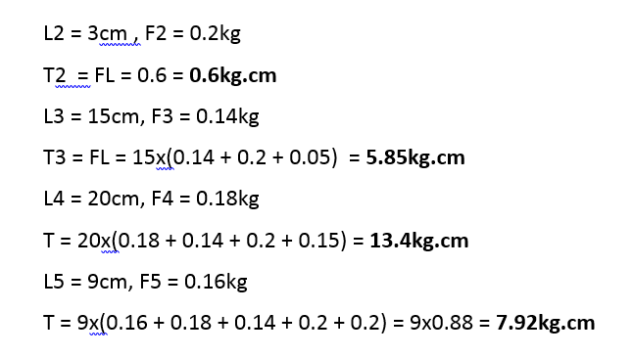

Components Used

Software

- Arduino IDE

Arduino IDE is a cross-platform software which is used to program micro controllers like Arduino, Node mcu and other boards. Its source code is written in java and is the most popular software used to upload code on the board. Arduino IDE supports C and C++ programming language which follows the following structure:-

- Initialization - declaring libraries and variables
- Setup code – Starting communication and setup
- For Loop – Forever repeating block of code

- MIT App Inventor

MIT App Inventor is an open source tool created by Google and maintained by MIT to make the process of app building easy. Little programming knowledge is required and the tool contains a lot of build-in block templates which makes the task easier.

- PubNub


PubNub is a global data streaming network that has real time data transfer capability. It can even be use for IOT and supports the library for Arduino IDE.

Github - https://github.com/pubnub/arduino

The reason I chose Pubnub over other IOT is as follows:-
- Has Real time data transfer capability
- Unlimited devices can be connected
- 1 million times data can be transferred per month for free

Hardware

- Node Mcu
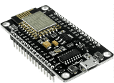
Node Mcu is an open source microcontroller used mainly for IOT due to its inbuilt WIFI capability. Developed by Espressif Systems and is compatible with Arduino IDE. Node Mcu which I am using is V2 and here are the pinouts below
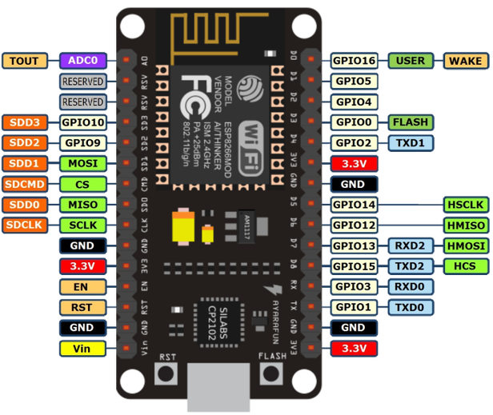

- MPU9250 IMU Sensor
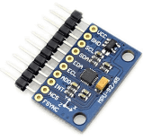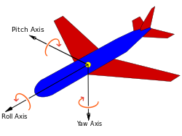

IMU stands for Inertia Measurement Unit which can detect real time orientation of an object in 3D plane relative to earth using Yaw, Pitch & Roll readings. MPU9250 has inbuilt Gyrometer, Accelerometer and Magnetometer which can detect readings on different plane.

This sensor will be placed on 3 different location of arm to get accurate reading of that location.

Another added benefits of using above sensor is the easy usage of library. Bolder Flight system has easy setup library code compared to others and hence easy implementation.
Github link - https://github.com/bolderflight/MPU9250

- Servo Motor
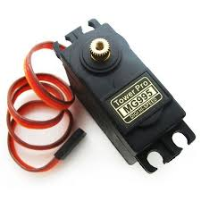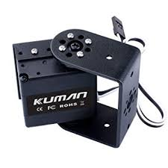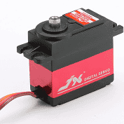

Servo Motor are important role to play in controlling mechanical arm. Strongest motor is Jx which has 32 kg.cm torque, followed by Kuma with 17kg.cm and MG995 with 10kg.cm
Each motor will be placed in different location starting with Jx as the base and MG995 at the tip.

- Hand Suction
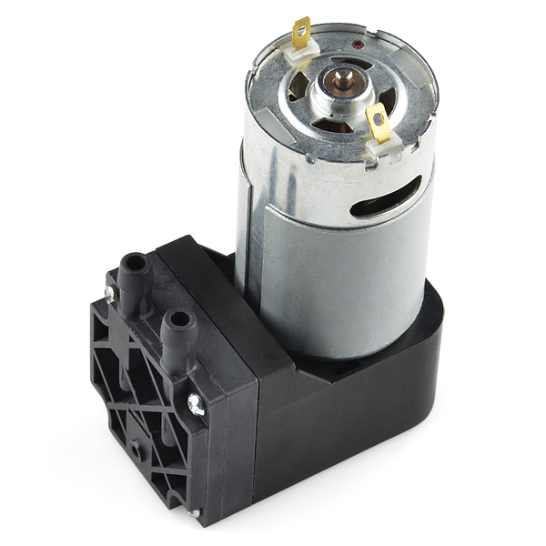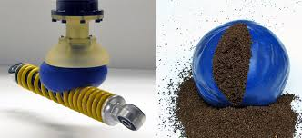

Suction motor will be connected to balloon with nylon wires. Balloon will contain granular material like tea leaf which will solidify when the air is sucked out. This results in balloon taking the shape of material which it hold and picks it up easily.
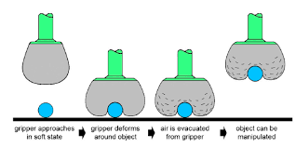
- 12V DC Motor
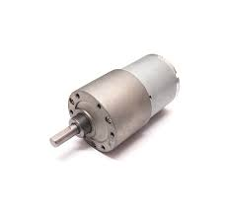
This DC motor will be the base of the robot which will provide the locomotion to the body. There will be 2 motor like this attached to bottom base at the back and one caster wheel in from for stability.
- Raspberry Pi V3 and Pi camera

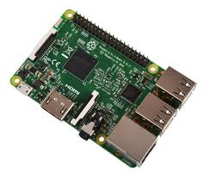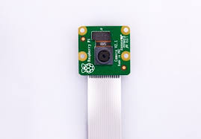

Rapsberry Pi is a microprocessor which is capable of doing complex programming and data transfer. For this project I will be using Raspberry pi to take video from pi camera and send it on mobile app.

Construction
First I had to take 2 rectangular wood base of 30x40 cm and modify it by using a driller for making the appropriate hole for mounting. The I took threaded rods and insert it on 4 corners of one wood base. By using spacers and bolt to sandwich between the base so that it will hold it intact. Same process went for the top base.
Top base has a rectangular hole to mount the first servo. That mount was created using a saw machine and fillet. Once the 2 wood assembly is done then we move on to assembly of arm.
Arm has 4 parts which were designed on CAD software and made by 3D printer using nylon filament. Printed parts has necessary mount holes so that servo motors can be attached. Holes of some parts were off aligned so that problem was solved by using soldering iron to modify the parts. Once all the parts are printed then assemble it according to the design. But before we join the arm, we have to set the servo motor at the right angle so that it only moves from 0-180 degree in the desired direction.

Location | Servo used | Starting Angle | Servo range | Placement of parts
D1 | Jx servo | 90 | 140-30 | Perpendicular to wood base
D2 | Kuman | 90 | 10-110 | Horizontal to ground
D3 | MG995 | 0 | 0-180 | It should rotate 0-180 comfortably like your right hand
D4 | Kuman | 0 | 0-105 | Perpendicular to ground
D5 | MG995 | 90 | 0-180 | Perpendicular to ground

How the system works?
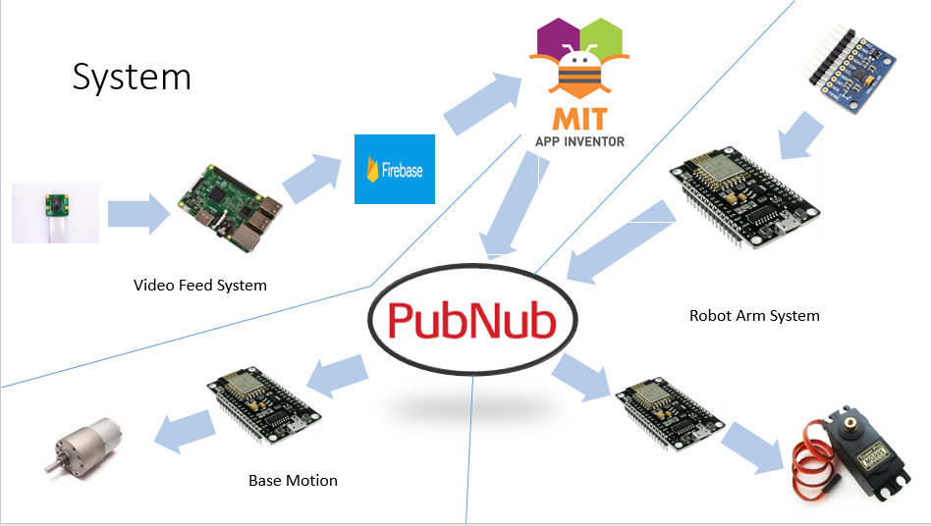
This project is the combination of 2 system. One part controlls the base motors with mobile app and another controls a robotic arm with gestures. All the communication happens through wifi and PubNub is a realtime IOT platform used to transfer all the data. Mobile app which controls base motor is made from MIT app inventor and it has a joystick interface. While the robot arm is moved by servo motor and it is controlled by IMU sensors attached to a persons hand. The node mcu sends the IMU sensor to pubnub which is received by another node mcu as servo angles and it controlles the servo motors. The suction is controlled by pressing the button on hand to switch it on and off so that it can lift up the object.
Mobile app
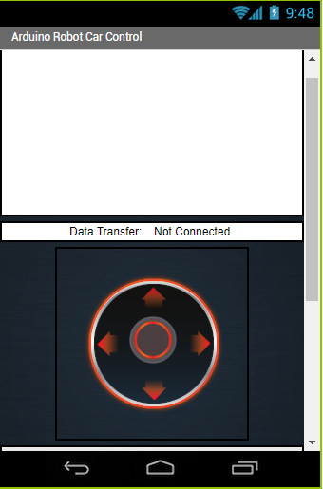
Joystick is the red one which controls the base motor. When data trasfer begins, the middle text gets converted from ‘Not Connected’ to ‘Connected’. Top white space is kept for video feed.
Below image is the backend of program which sends the coordinates taken from the joystick and sends it to node mcu which process it and decided where the robot should move.
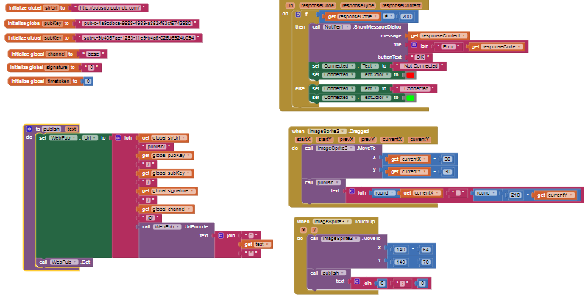

Hand Controller
Controller is made by attaching all the components with sewing on the cloth making it a wearable tech. IMU sensors detect the angle of your hand and sends it through WIFI.

Controller Circuit
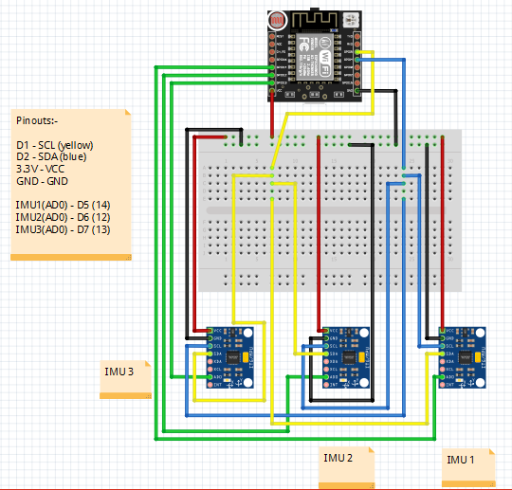
In the above circuit, 3 IMU sensors are connected to same pins of node mcu. This is because the sensor works on I2C communication so it needs to be connected to D1 & D2 pin for it to work. To connect multipe sensors, we use I2C bit bashing technique which takes the data from each sensor individually at a time. Above circuit also needs to have buttons which controls the suction.

Publisher Code:-

Below is the screenshot of code that publishes the sensor data to pubnub. In the setup the microcontroller connects to wifi from my mobile hotspot. In the loop, it collects the sensor data and converts it to angle for servo motor. Later we arrange the data to JSON format which is a requirement to upload the data on server. JSON formatting is done using ArduinoJSON library automatically.
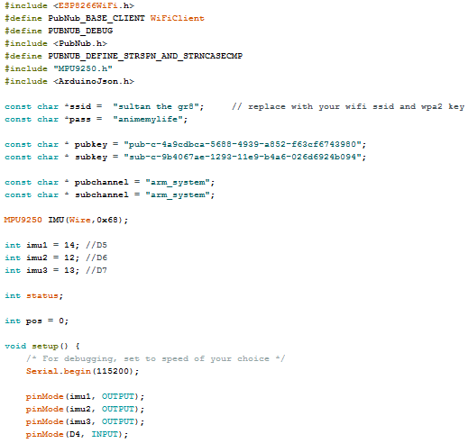
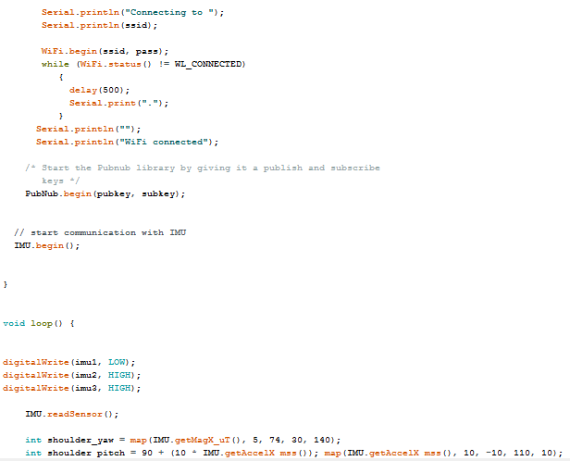
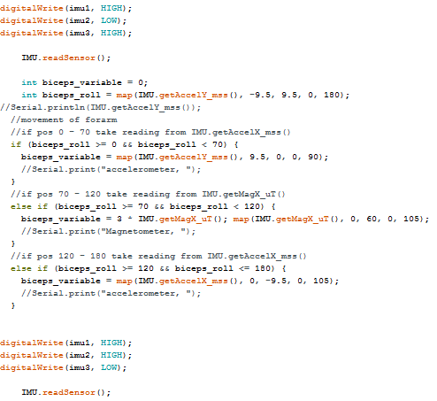
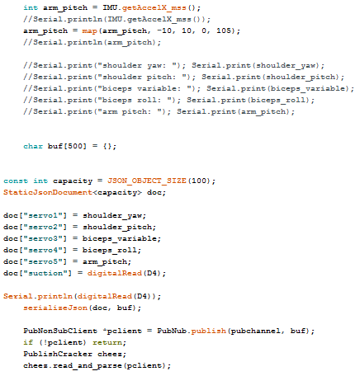
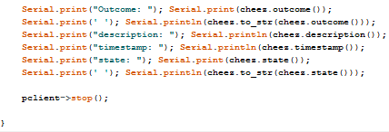
Telepresence Bot Circuit
This bot has wiring of 2 systems, Arm and base. Both of the circuit images are given below:-

Robotic Arm Wiring
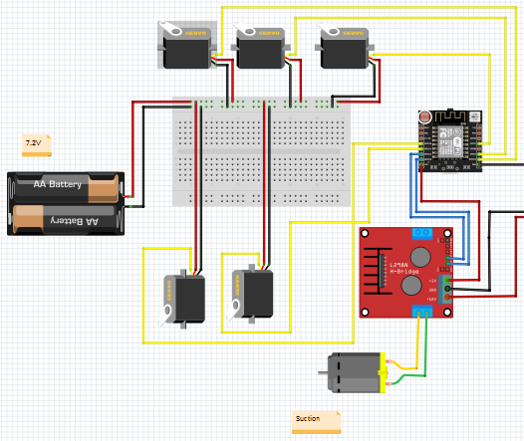
Arm system includes connection from power supply to voltage regulator that converts from 12V to 7.2V which is supplied to multiple servo motors. While 12V is directly supplied to driver which supplies to node mcu and suction.

Arm System Reciever Code:-
Reciever code has similar setup like the publisher. When node mcu recieves the information, it converts information from JSON to integer and uploads to servo motors.
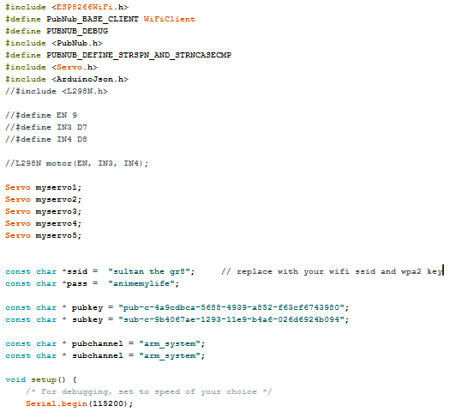
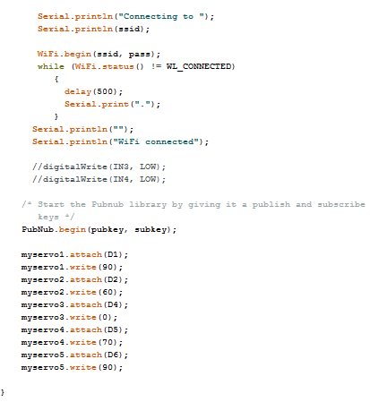
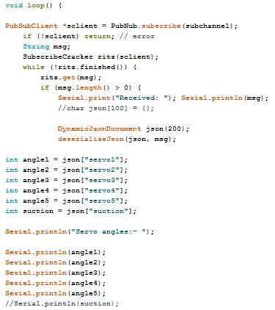
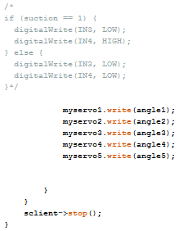
Base Wiring
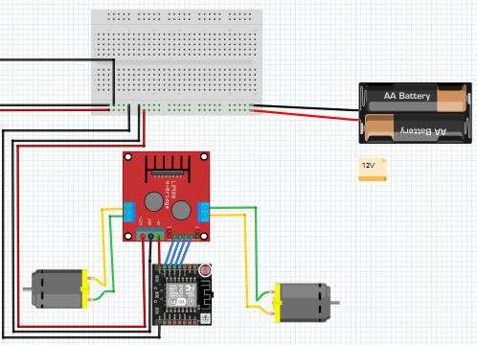

Base motor code:-
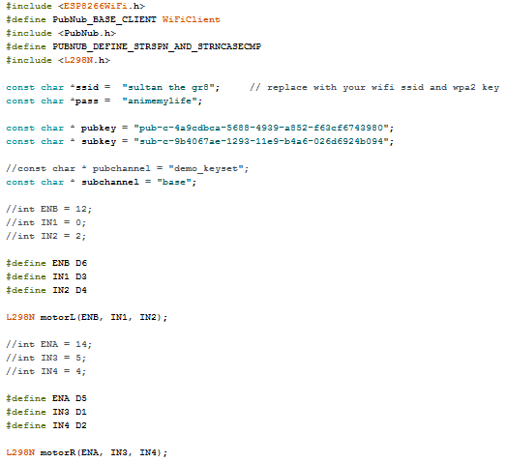
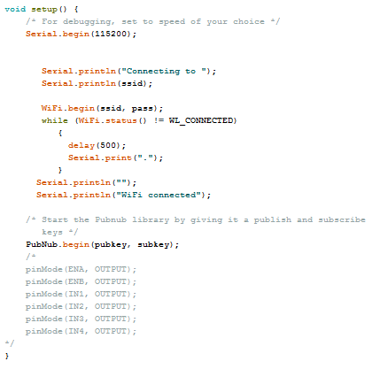
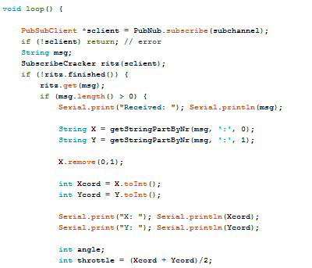
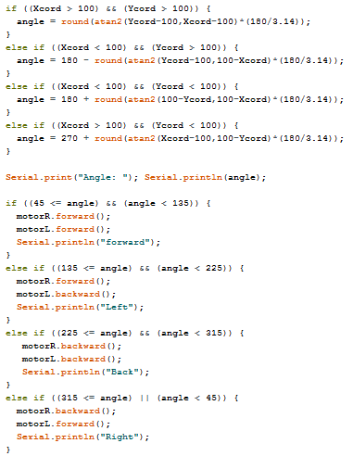
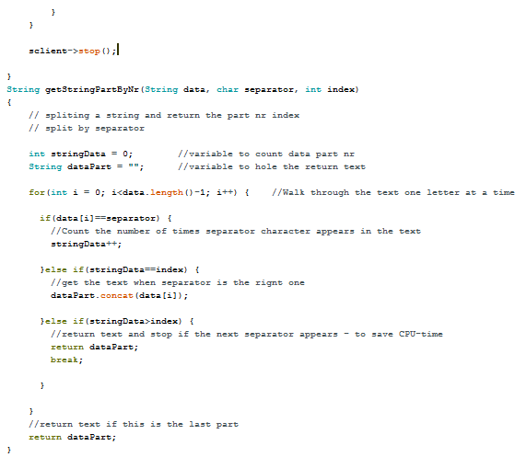

Conclusion
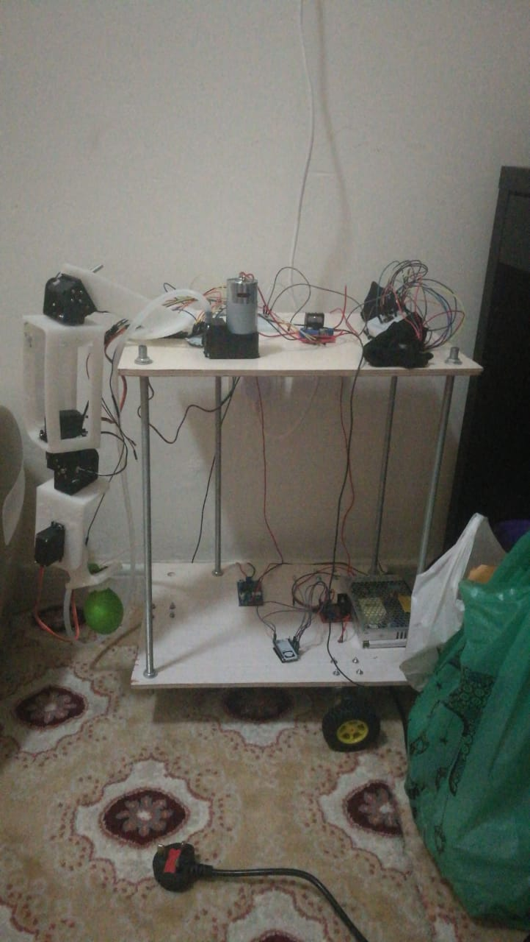
Project was implemeted successfully where I was able to control servo motors and base motor in real-time. This proves the concept of controlling an environment with telepresence on different part of the world. However, there are some challenges that I face when working on this project:-

- High Power Consumption
Since we are controlling 8 heavy duty motors so we need high amount of current to power the whole system together. I used a power supply of 12.5A but it needs attachment to home power grid which hinders its mobility.
- Delay in arm movement
Reaction of arm is real-time but with delay of 1 second. That is still a good result and can be improved upon. While the data transfer takes only 0.25 second, another 0.75 seconds is taken by servo motors to react to the data. It is more of a hardware issue than software. This means by using better specs of microcontroller and servo motors, faster reaction can take place.
- Complication in Video transmission
I planned to do video transmission from raspberry pi to mobile app but there is complication in that. It is easy to do video transmission from same network but challenge is in doing video transmission over 2 different network. This area is a whole different part of research and due to less time, I did not implement it.

Potential Improvements
- Rechargeable battery to power each system
This is the best way to power up the full system so that robot doesn’t have to be stuck with cable cord. A battery of at least 7A with low weight is preferred.
- Self-locking nuts and caster wheels to stabilize the vibration
One mechanical mistake I made is to use normal nut to join 2 wood base. This caused to base to get loose over time and starts vibrating. This instability can be solved by using self-locking nut which won’t get loose over time.
- Better gripper design to lift up object
Current gripper needs to apply huge force downward to take the shape of object. This puts a stress on the servo motors and structure of arm. Better design can be implemented to make the lifting part smoother. Instead of using a suction, normal servo gripper can be used which will consume less power and easier to control.
- Better specs of microcontroller and servo motors for fast reaction
To reduce the delay of system reaction, better specs of microcontroller and servo motor can be used to achieve faster reaction.

