

There’s a project being developed that I’d like to make you aware of. It could modernize our transportation infrastructure in a way that will allow it to pay for itself, while enhancing environmental protection and solving our economic problems. It will create an intelligent, decentralized, self-healing power grid. It’s really an economic stimulus package in itself: the New Deal of the 21st century.

The project is detailed below:

The Solar Roadways – rebuilding our infrastructure and our economy

The Solar Roadways consists of structurally engineered solar panels that we drive on. Each Solar Road Panel (roughly 12’ by 12’) interlinks with neighboring panels to form the Solar Roadways system. The Solar Roadway replaces our crumbling petroleum-based asphalt highway infrastructure with an intelligent road that pays for itself through the generation of electricity. The Solar Roadway generates electrical power from the sun and becomes our nation’s decentralized, intelligent, self-healing power grid, replacing our current deteriorating power distribution infrastructure.
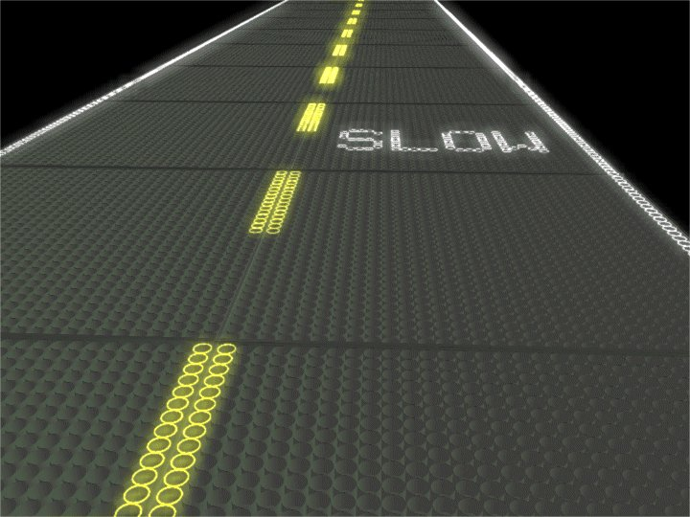
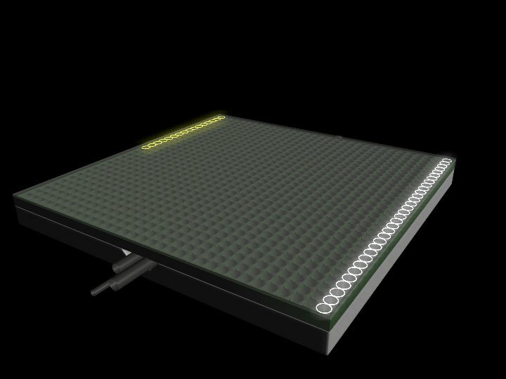

The Solar Roadway distributes its electrical power to all businesses and homes connected to the system via their parking lots and driveways (made up of Solar Road Panels). In addition to electrical power, data signals (cable TV, high-speed internet, telephone, etc.) also travel through the Solar Roadways, which acts as a conduit for these signals (cables). This feature eliminates the unsightly power lines, utility poles, and relay stations we see all over the countryside. It also eliminates power interruption caused by fallen or broken electrical lines or poles.

Each Solar Road Panel uses some of its own power to light up embedded LEDs, which “paint” the road lines from beneath the road surface. This feature also allows messages to be spelled out on the road surface, such as “SLOW DOWN”, or “ACCIDENT AHEAD”. Road lines can be instantly “repainted” to direct traffic to a single lane or to detour. This eliminates the need for cones or flares. Better visibility at night: with the road lines illuminated, it will be like driving on a well-lit runway.

The Solar Road Panels heat themselves for snow and ice removal in northern climates. No more need for snow removal or school/business cancellations. These safer driving conditions (roads lit at night, no snow/ice, etc.) will prevent many accidents and allow for reduced insurance rates – both health and automotive.

All additional power (unused by the panels themselves) is sent “down line” to homes and businesses. We could produce three times the total electrical power used by the United States and almost enough electricity to power the entire world. No more power outages, roaming or otherwise.

The Solar Roadway produces clean, renewable energy. No pollution, no greenhouse gases, no by-products, and the Solar Road Panels are completely recyclable or reusable. My understanding is that roughly half of all greenhouse gases are produced by fossil fuels used for the creation of electricity. The Solar Roadways eliminates this (half of the cause of Global Warming) entirely.

The Solar Roadway, being an “electric road”, will also make all-electric vehicles more practical: recharging stations can be placed in all parking lots and rest stops. This will allow the all-electric vehicles to have the same driving range of current internal combustion gasoline- or diesel-powered vehicles. Elimination of internal combustion engines, which would now be feasible with the Solar Roadways, would wipe out most of the rest of the causes of greenhouse gases.

There are many, many other features, including wildlife preservation, the elimination of impervious surfaces, law enforcement, DUI detection, counter-terrorism, etc. Most of these features are spelled out in detail on our website:
www.solarroadways.com

Scott Brusaw is an electrical engineer (MSEE) living in northern Idaho, where he’s built his own electronics lab for developing the Solar Roadways. Prior to moving there in 2001, he had served as the Director of Research and Development for the engineering department of a manufacturing company in Ohio for over 12 years. He was also on their Board of Directors and was a voting member of NEMA (National Electrical Manufacturer’s Association).

In 2009, the Federal Highway Administration (FHWA) awarded Scott Brusaw with a 6-month $100,000 Phase I SBIR contract to build the first Solar Road Panel prototype. The prototype demonstration was captured on video by the YERT team:
http://www.youtube.com/watch?v=Ep4L18zOEYI

After finishing this contract and turning in his findings, the FHWA invited Scott Brusaw to apply for Phase II funding. The 2-year $750,000 contract was signed in July 2011 and Mr. Brusaw is on schedule to begin building the first prototype solar parking lot in the spring of 2012.

In order to build highway-grade prototypes, Penn State has quoted $15-25M. Norwich University needs $2.5-5M for their part in developing the internal support structure, and Solar Roadways Inc. will need $2-3M for the electronics development. So a conservative estimate is $50 million is needed for the research and development and ramping up for manufacturing of a system that could very well upgrade our roads and power grid at the same time while weaning our nation off of fossil fuels and foreign oil. The Solar Roadway is a system that will put America back to work (2.5 million new full time jobs in panel assembly alone) for years to come and make us an exporter of energy again for the first time in decades.

Before we eagerly invest in antiquated technology – asphalt and overhead power lines – let us consider what will be needed to take our nation through the 21st century. We need an intelligent highway infrastructure and a self-healing decentralized power grid that will eliminate our need for fossil fuels. We can have this and more in the Solar Roadways.

As I’m sure you are aware, the price of petroleum-based asphalt is exorbitant and no longer a feasible material for our road surfaces. When Solar Road Panels are refurbished, the solar cells will be upgraded to whatever the newest technology is at that time, which will allow them to keep up with population growth and increased energy needs.

We can put America back to work: it will take roughly five billion Solar Road Panels to cover the roads, parking lots, and driveways in the U.S. We envision building factories in every state and creating literally millions of new “green collar” jobs.

The Solar Roadways can save our wonderful country. Your help could make this an historic event in the history of our great nation. Everyone is looking for answers to our deteriorating highway infrastructure, our crumbling power grid, and the climate crisis. We truly believe that the answer is the Solar Roadways.

Please get together with your fellow leaders and draft a bill to fund this great project. I would love to see our state be one of the first to implement this technology on our parking lots, roads, and more. Imagine the amount of jobs it will create for our state and what it will do for our economy!
In summary, the Solar Roadways will:

- Create an intelligent, secure highway infrastructure that pays for itself
- Create an intelligent, secure, decentralized, self-healing power grid
- Eliminate the need for coal-fired or nuclear power plants
- End our dependency on oil and other fossil fuels (coal and natural gas)
- Cut our nation’s greenhouse gas emissions by over 50%
- Provide safer driving conditions

Solar Roadways was presented at a TEDx Talk in Sacramento:
http://www.youtube.com/user/TEDxTalks#p/u/0/nvWTaqUvsfA

The YERT YouTube video titled: Solar Roadways – the Prototype has gone viral with over a million views as of this writing:
http://www.youtube.com/watch?v=Ep4L18zOEYI

The Solar Roadways entry in GE’s Ecomagination Challenge won first place (twice – in round 1 and round 2!) in the popular vote open to the general public world-wide:
http://challenge.ecomagination.com/ct/e.bix?c=ideas

CNN is currently running three segments on Solar Roadways:
Start Small, Think Big: http://www.youtube.com/watch?v=E9poqK8Xo8Q
Edge of Discovery: http://www.youtube.com/watch?v=ONB9rp_Msp8
Solutions: http://www.cnn.com/video/#/video/bestoftv/2011/12/01/baldwin-solar-roadway.cnn

Please feel free to contact Scott (scott@solarroadways.com) with any and all questions. Don’t forget to visit the Solar Roadways website at www.solarroadways.com.

Thank you for your time.

