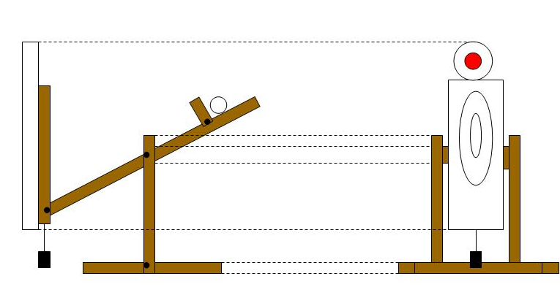
Moving Target Plan Mk1. [up/down]

The way the target works is quite simple. The target consists of a see-saw type constriction with a paper target attached to the end of the moving bar. The central bar consists of two beams of equal length bolted in the middle allowing it to rotate. At the back end the beams have another beam across the gap. On this rests a tube filled with concrete [or similarly weighty substance]. When the pin is removed from the uprights this weight will cause the beam to drop downwards and when it reaches the floor it will begin to roll off. The target will remain in the air, in its elevated position, as long as the tube is on the beam. When the tube reaches the end of the beam it will fall of and the counter weight will pull the target back down to the floor. You can alter the length of this section in order to lengthen or shorten the time the target spends in the air; this will vary the difficulty of the shot. On the other end of the two beams is a wooden board with a paper/foam target attached. This is again, like the main beams, bolted in such a way that allows it to rotate. Attached to the bottom of this is a counter weight which is not as heavy as the concrete tube but enough to keep the target upright. If this weight is neglected and the target simply nailed to the other beams, it will stand up at an angle, pointing away from the shooter making the shot far too difficult. In order to start the mechanism, a pin on a string is put through the upright above the horizontal beam and slightly to the left. This ensures that the beam cannot rise without the target being activated. When pulled out the pin will allow the concrete tube to pull down the opposite side to the target and eventually roll off. To chain together a series of targets you could create a series of targets that are all joined such that a pin on a string is attached to the end of each target. In that way when on target falls the pin is pulled from the other target and so it continues.

Good Luck T,Cox

