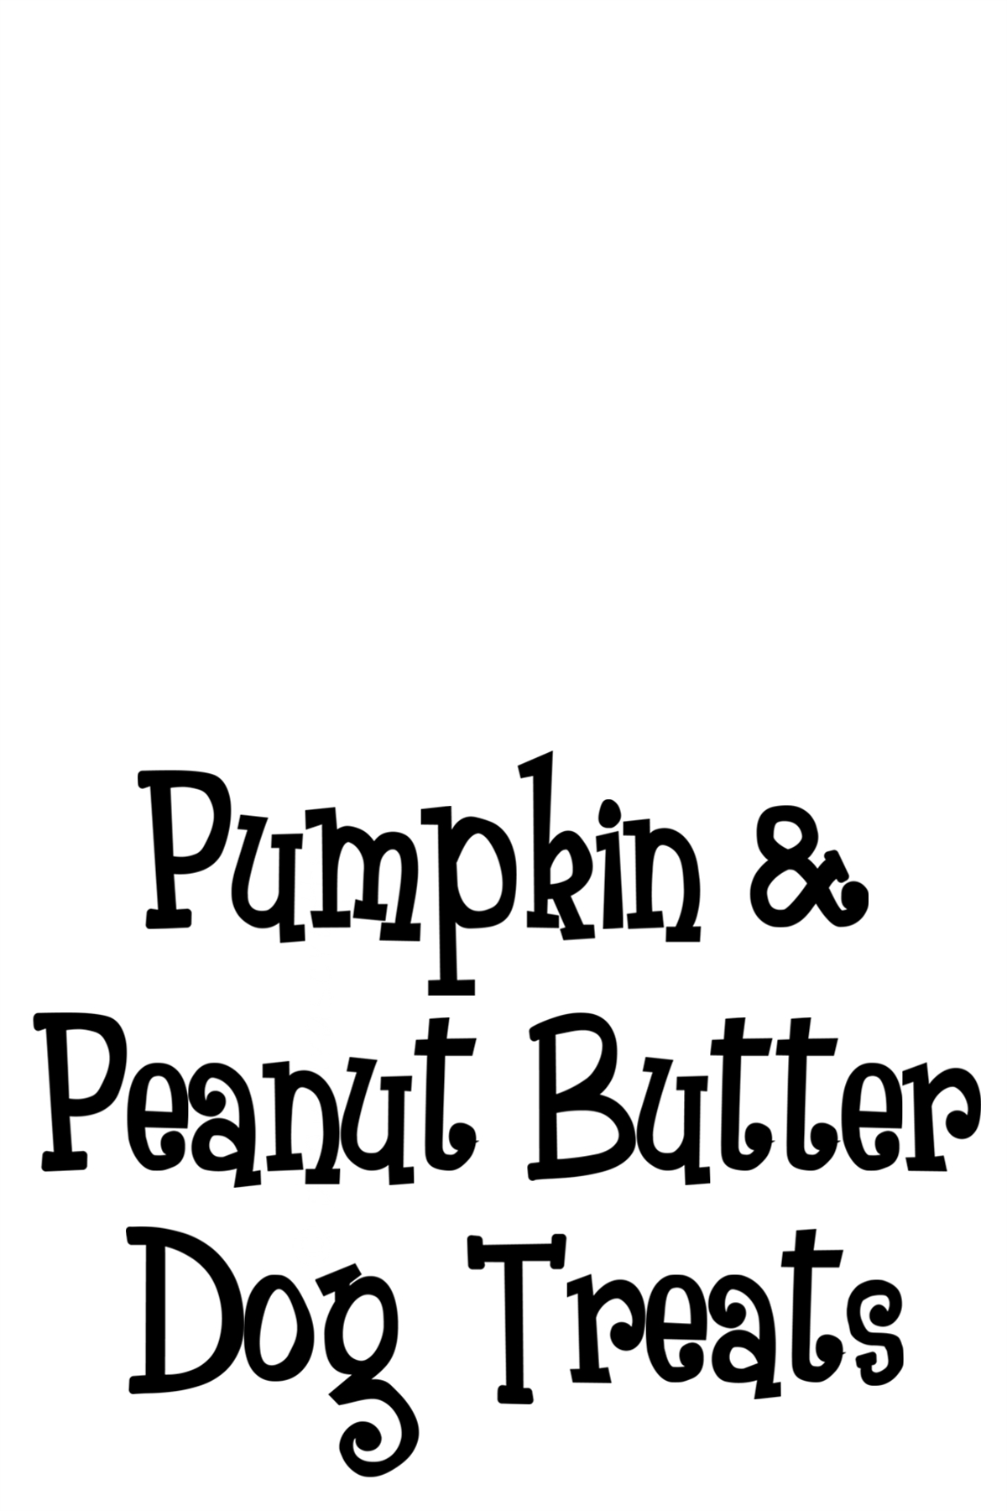
Pumpkin & Peanut Butter
Dog Treats
Ingredients: Whole wheat flour, pumpkin puree, eggs, peanut butter, salt and cinnamon.
Store in an airtight container for up to three months.

Pumpkin & Peanut Butter Dog Treats
Ingredients: Whole wheat flour, pumpkin puree, eggs, peanut butter, salt and cinnamon.
Store in an airtight container for up to three months.

Pumpkin & Peanut Butter Dog Treats
Ingredients: Whole wheat flour, pumpkin puree, eggs, peanut butter, salt and cinnamon.
Sore in an airtight container for up to three months.

