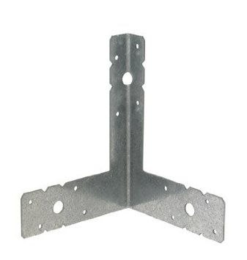
8 (6x8 Corner Tie) Brackets
$51.44

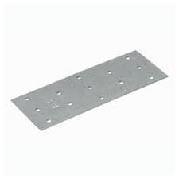

8 (5x1 13/16 Mending Plate)
$4.40

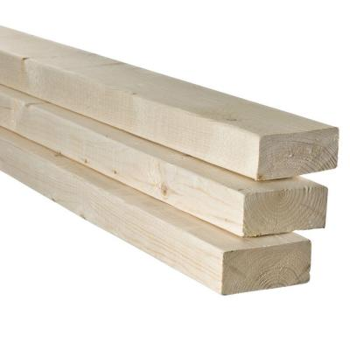

2 2inches by 4inches by 8feet $4.20
2 2inches by 4inches by 10feet
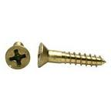
$5.90

1 small box of Phillips 6x1
$3.89

Total: $69.83

