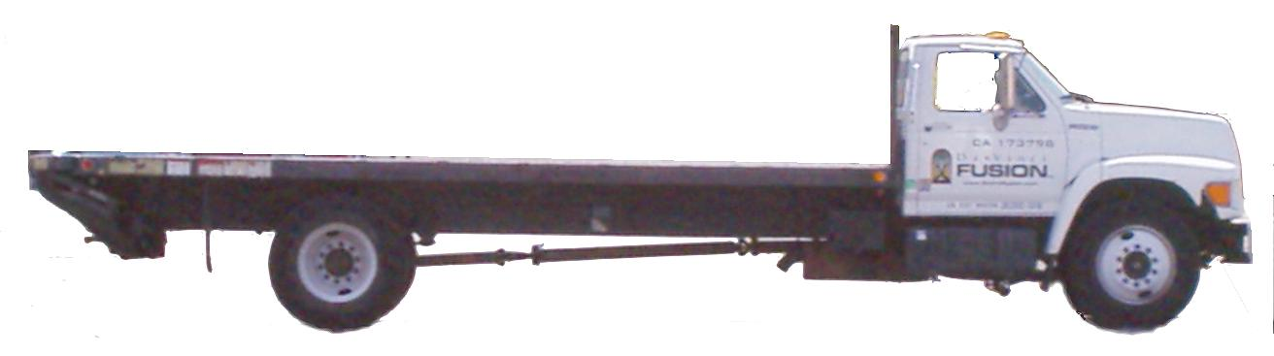

Abbreviated Pre-Trip Truck Inspection Check List
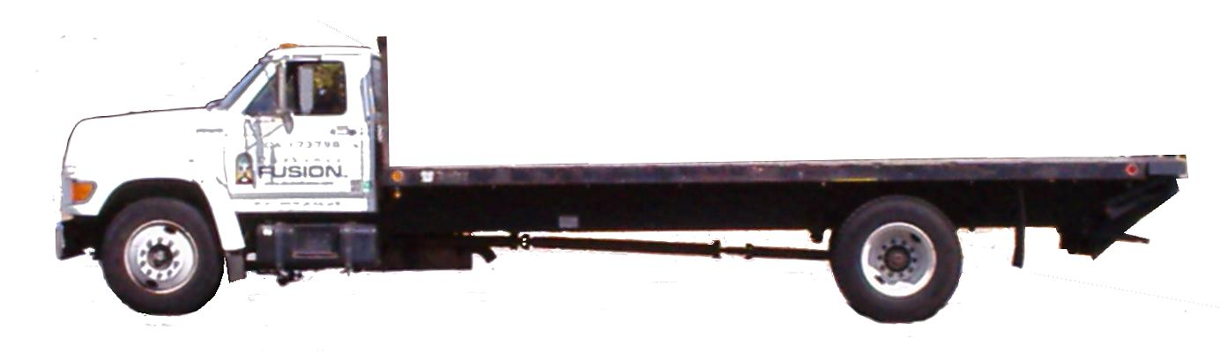
20-Foot Flatbed Truck, with Lift-Gate and Optional Stake Walls:

Driver Side, Notes: Passenger Side, Notes:

Supervisor: ###-###-####

Warehouse: ###-###-#### Vertical Clearance Required For Vehicle (measure and note here):

Destination notes in margin →
Event / Company, Project Manager Address, City, State, Zip Code
Date: ___________ Driver: ____________________ Odometer: ______________ Destination(s):

⁪ Battery Last Checked: _____
⁪ License Plate Date: _______
⁪ Engine Oil / Wiper Wash
⁪ Brake / Transmission Fluids
⁪ Fan Belts
⁪ Coolant / Hoses
⁪ Leaf Springs: No Cracks
⁪ Tire Pressures / Condition
⁪ Drive Shaft / U-Joint
⁪ Undercarriage / Mud Flaps
⁪ Lift-Gate Functions
⁪ Load & Rigging Secure
⁪ Fire Extinguisher, Etc
⁪ Horn
⁪ Windshield Wipers
⁪ Headlights: Dim-Bright
⁪ Turn Signals / Brake Lights
⁪ Emergency Flasher Test
⁪ Steering: No Loose Play
⁪ Reverse Lights / Beeper
⁪ Ratchet Straps (hook only)
⁪ Insurance Expires: ________
⁪ Registration Exp: _________
⁪ Windows & Mirrors Clean
⁪ FasTrak / CFN Fuel Card
⁪ Cell Phone is Hands-Free
⁪ GPS is Hands-Free
⁪ Flashlight, Area Floodlight
⁪ Dashboard Gauges Function
⁪ * Axle Weights (see below)
⁪ ** Fuel Status (see below)
⁪ Brakes / Parking Brakes

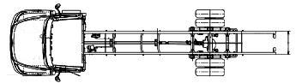
⁪ Condition of vehicle is satisfactory, and within weight limits. Cargo is adequately secured.

GVWR: 26,000# (= 13,940# max payload)
Front GAWR: 7,000# (= 1,260# max payload = 1/10th rear axle payload)
Rear GAWR: 19,000# (= 12,680# max payload = 10x front axle payload)
* Formula for determining approximate axle weights:
Front Axle: 14,103 - ( 77.9 × avg leaf spring-to-frame mm)
Rear Axle: 82,362 - (209.5 × avg leaf spring-to-frame mm)

Front Axle (7,000# max) Rear Axle (19,000# max)
Left-Front: Left-Rear:
_______mm _______mm

Right-Front: Right-Rear:
_______mm _______mm

= Average: = Average:
_______mm _______mm

14,103 82,362
- (77.9 × avg mm) - (209.5 × avg mm)

Front Axle = ___________# Rear Axle = __________#
A convenient reference point:
Public Scale Weight, Empty, with ⁷/₈ tank of fuel: 12,060#
Steer (Front): 5,740# (107.50mm avg leaf spring-to-frame)
Drive (Rear): 6,320# (363.00mm avg leaf spring-to-frame)

Center of gravity of payload (assumed forward of rear axle):
(Front Axle# - 5,740#) + (Rear Axle# - 6,320#) = Total Payload#
(Front Axle Payload# ÷ Total Payload#) × 237.25" Wheelbase
= Center of Gravity, measured in inches, forward of rear axle
To shift load: ÷ desired Front Axle Payload# by Total Payload#

Common load densities:
Diesel fuel weighs 7.15# per U.S. gallon x 100 gallons = 715#
Aluminum stagelight trusses weigh 5# to 7# per cubic foot
Solid lumber and plywood weighs 35# per cubic foot
Concrete weighs 147# per cubic foot; Stones 104# per cubic foot

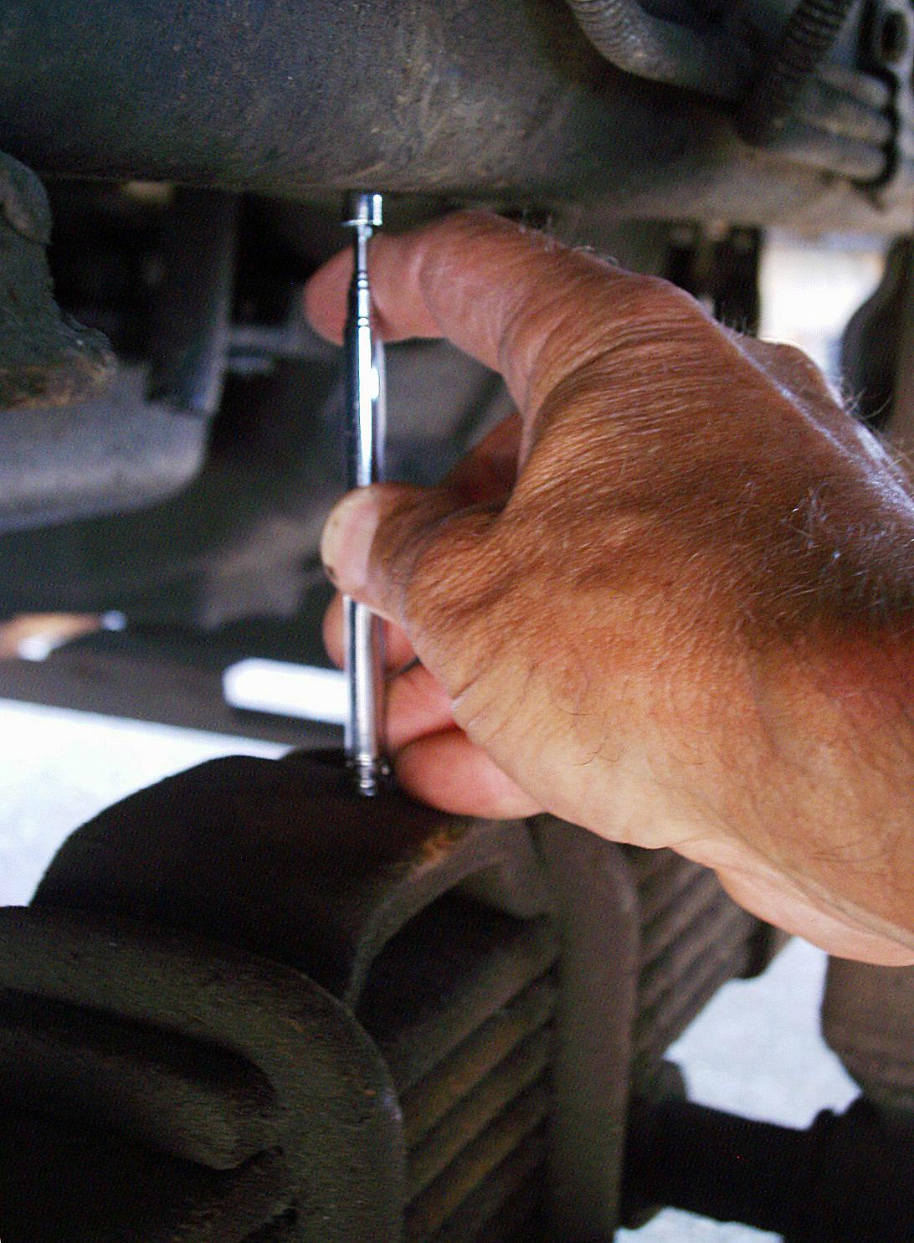
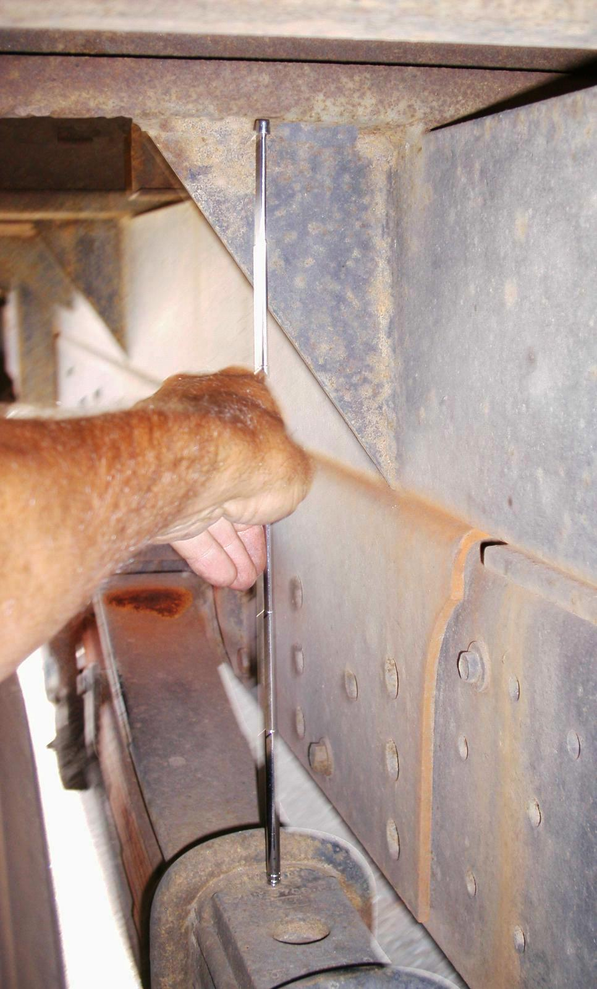
1998 Ford F800 F Series
VIN: #XXXX##X#XXX#####
California License Plate Number: #X#####
Category: Flatbed Truck
Style / Body: Conventional Cab
Front Disk Brakes, Drum Rear Brakes
Tires: 10R 22.5F, 100psi cold
Engine: ISB Series, 5.9L (= 359 CID), L6, Diesel

Flatbed Max. Dimensions: 21' 2.5" long × 8' 0" wide
Flatbed Height (empty): 4' 3" = loading dock height
Flatbed Capacity: 13,900# maximum payload
Lift-Gate Capacity: 2,500 lbs
** Dual 50-Gallon Fuel Tanks
Total Truck Length: 30' 2.5"
Wheel Axles Wheelbase: 19' 9¹/₄" (= 237.5")
GVWR Type: Class 6 (GVW 26,000# max)

** Mileage: 10.9mpg highway driving @ 40% payload capacity; 7.2mpg city driving @ 40% payload capacity
** Each fuel tank holds 50 gallons of diesel fuel, but only 46.5 gallons is usable. Step-tanks located below driver and passenger doors
** Onboard fuel gauge understates remaining fuel: Use calibrated wooden fuel dipstick!
Fuel dipstick (¹¹/₁₆" wooden dowel, 21³/₈" long) calibration, in U.S. gallons, for 50-gallon step tanks:
0 gal.= ³¹/₃₂"; 5= 2¹/₈"; 10= 3⁷/₃₂"; 15= 4⁵/₈"; 20= 5¹³/₁₆"; 25= 7⁵/₁₆"; 30= 8²³/₃₂"; 35= 9³¹/₃₂"; 40= 11³/₈"; 45= 12³/₄"; 46.5= 13⁷/₃₂"

For More Information: http://www.instructables.com/id/How-to-Estimate-the-Axle-Weights-of-a-Standard-2-A/

