Plane 1
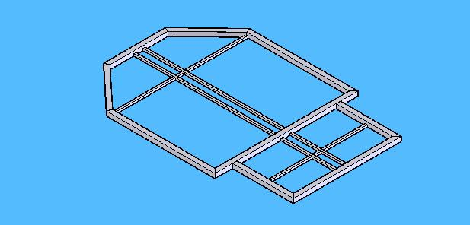
Ground plate, all in one plane. Mostly perpendicular corners. Cross tubes where the seats are mounted on are not drawn.

Plane 2
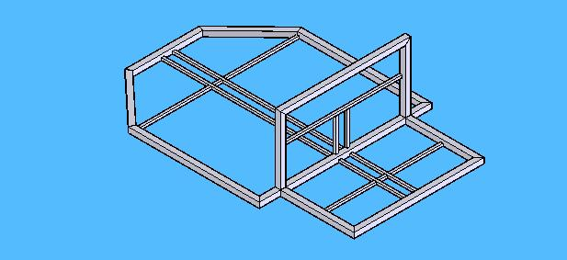
Plane separating driver & passenger from fuel cell. All perpendicular corners.

Plane 3
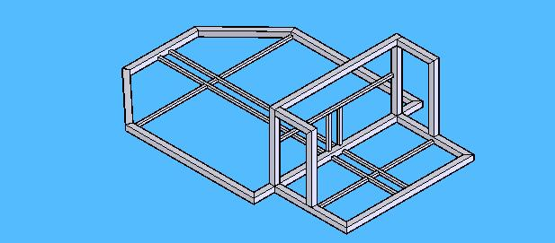
Rest of the suspension tubes. Two perpendicular corners: pre-fab on flat surface and the mount on chassis.

Plane 4
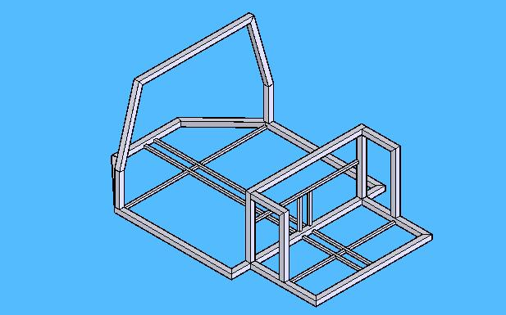
Roll-bar for driver & passenger. Corners are not perpendicular but it can be made pre-fab on a flat surface.

Plane 5
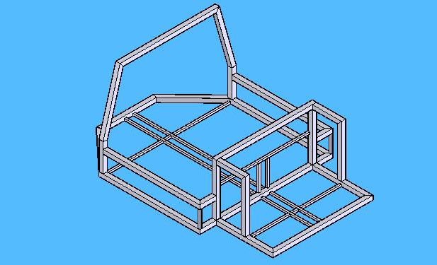
Side impact bars. Construct 2x2” tubes in one plane, then welded on the chassis with 1x1” tube.

Plane 6
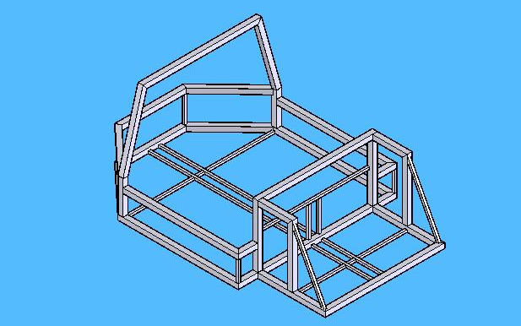
Rear bars (where rear suspension is mounted on). Same construction method as Plane 5.
Plane 7
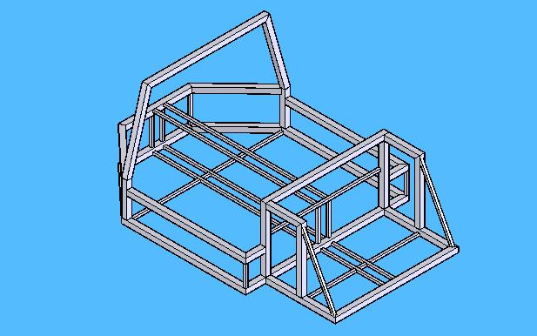
Bare bone (1x1”). Vertical tubes are not drawn but can be placed where necessary.

Plane 8
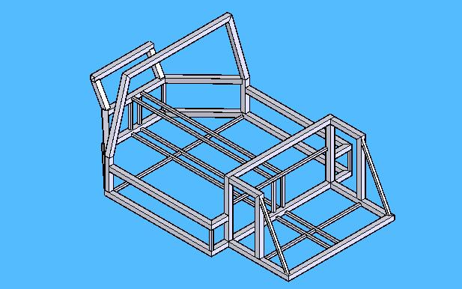
Bars for rear shock.

Plane 9
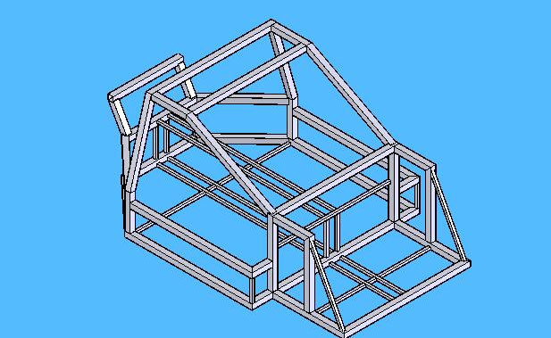
Roof construction. First the two side bars can be made pre-fab on a flat surface, then the two cross members can be placed.

Plane 10
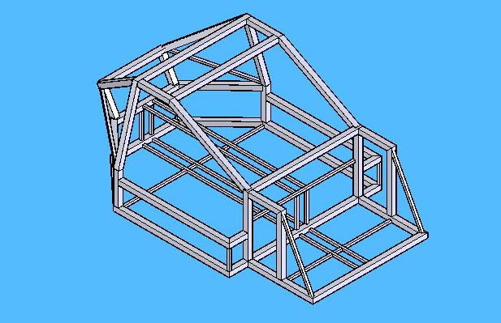
Last section of the roof (on the rear). These tubes are hard to construct; requires a skilled metal worker.

