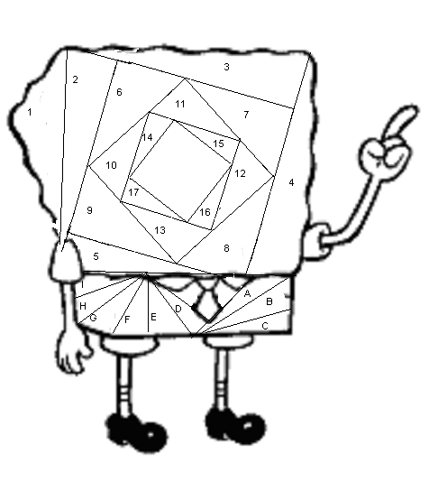
Yellows:

Pattern 1:
1,2,6,10

Pattern 2:
3,7,11,15

Pattern 3:
4,8,12,16

Pattern 4:
5,9,13,17

Whites:

Pattern 1:
A,D,G

Pattern 2:
B,E,H

Pattern 3:
C,F,I

Yellows:

Pattern 1:
1,2,6,10

Pattern 2:
3,7,11,15

Pattern 3:
4,8,12,16

Pattern 4:
5,9,13,17

Whites:

Pattern 1:
A,D,G

Pattern 2:
B,E,H

Pattern 3:
C,F,I
