
ToxicTom's Trash Tongs
6"
30"
4"
3/4"

3/4"

5"

Materials:
½” or ¾ " PVC pipe 36” long
½” or ¾ " PVC elbow
48" recycled banding strap (1/2” or 5/8”)
Rubber bands
Duct tape
½” sheet metal screw

Tools:
Safety glasses
Dremel tool with cutoff disk
Pliers
Aviation snips or tin snips
Hacksaw or crosscut saw
hammer

Instructions: (Please read completely)

- Cut a piece of recycled banding ~48", form a 12" loop on one end and secure it with a banding crimp, rivet or duct tape.
- Cut a 6" piece of PVC pipe for a handle and a 30" piece for the body (longer or shorter depending on user).
- Cut out a rectangle near the top of the body using the Dremel tool large enough for the banding to fit through (~1” x 2.5”)
- Cut a notch to secure the rubber band a few inches below the other hole or use the screw to loop the rubber band on.
- Put pipe together with the elbow.
- Cut the middle of the banding loop and bend as shown.
- Feed the banding through the pipe, out the hole and bend the handle as shown on the drawing or in photo. Snip off excess
Grabbing fingers
Bend one up, one down and do the same on other finger so they mesh when they come together.
- Attach to the handle with duct tape.
- Make a 3/8" cut in the middle of each grabbing finger.
- Bend each grabbing finger slightly so they intermesh. (1up, 1down)
11. Tweak bends as needed to make everything work.
These trash tongs can be made for about 20¢ each using recycled metal banding, PVC pipe and duct tape. Ask for scrap banding at your local lumber yard. If you have access to a crimper for the banding, use it to form the loop, if not use duct tape. After you make a couple you don’t really need to measure anymore. You can also put a 90º twist in the banding a few inches from the bottom to make the fingers perpendicular to the handle, but it's not necessary. Tweaking them to work properly is a cinch. Not enough return tension, add a rubber band. Not springy enough, bend banding as needed. Not grabbing good, bend the fingers as needed. I used 5/8" banding in 1" PVC pipe for most, but made a couple child sized ones with 1/2" banding and 1/2” pipe. Kids love to use them! They’re also great for people with bad backs (i.e. middle aged geezers like me).

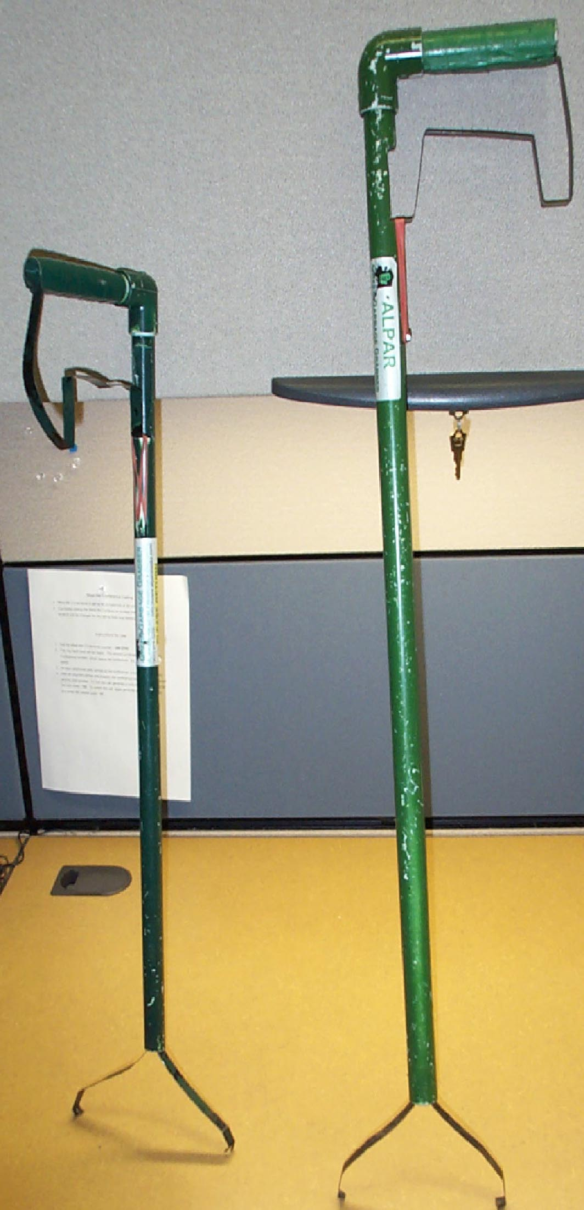
They are extremely simple to make and you can build them to fit the user group, just cut the pipe and banding to size. My 5 & 7 year old kids made their own and now love to go on "trash walks". I made 36 of them in about 4 hours. Setting up an assembly line would really cut the time down. To set up an assembly Iine I envision using a chop saw to cut the pipe to length and a router table with a couple of stops instead of a Dremel to make the cutout in the PVC. Using a self tapping ½” screw instead of cutting a notch to attach the rubber band will also speed up the assembly process. I don’t bother using PVC cement because it’s full of nasty chemicals and isn’t necessary. I’ve been taking the ones I made to various clean up events around my community for the last 5 years and have had nothing but praise for them. I install spare parts (a couple extra rubber bands) on each grabber for field repairs.

Caution: The banding on the fingers is very sharp and could seriously cut someone if you grab them, so make sure kiddos are warned that this is a TOOL and not a toy!

They are great for picking up paper, bottles and most other litter; they'll even pick up a dime. However, they will get bent out of shape if you try picking up things that are too heavy or stuck for some reason. I’ve been able to carefully pick up a full gallon jug and a paving brick.

Completed they should look something like this.

The small one has the finger perpendicular to handle and
is made from ½” banding & ¾” PVC pipe.

The fingers on the tall one are in line with the handle.
It is made from 5/8” banding & 1” PVC pipe.

