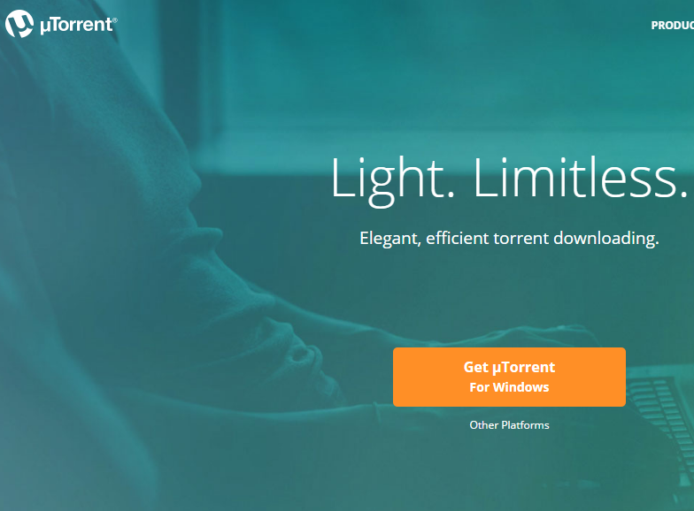**Free Things on the Internet**

**Which ones of us does not like free things in this world? They say everything has its price and it does. But if you are intelligent enough to get around this then it means something to be educated. And I have been doing this for about 12 years now, and dont ask me how I became so educated, I dont remember. LOL. Well if you do like free things then I am gonna educate you how to get all of these things for free. So if you like free music I am gonna teach you how to get all of the free music you can stand. My music collection is so big I could never listen to it all in a life time or 2. And do you like movies, I have about 60 movies I have not watched yet and there is a couple of 2014 movies but a big majority of them are either 2015 movies or 2016 movies, and the neat thing about it is you can download these movies while they are still at the movie theatre so right after they come out you can download these movies. And software whatever your heart desires as long as you can type in a search you can find whatever you desire. And yes I have even had a couple of $6,000.00 dollar pieces of software that I burnt to CD because they were so far above my head they were game writing software which I thought would be neat to learn how to do but they were so far above my head I would have been an eternity learning how to do any of it so it got burnt to CD and then later thrown away. But every piece of software I have on my PC has been downloaded for free. So you see music, movies, and software whatever you desire it is all free. Now I will have to educate you somewhat on the software. It is all free but some of it has key generators and you have to run the key gens and it will give you a serial number for the software and then you input the serial number into the software when it ask you for the serial number and then you have a complete version of the software. Now some of them comes with the serial number and usually it is in notepad usually and sometimes it is in Microsoft Word and you just open up either one and it gives you the serial number and you input it into the software you want and then wallah a full working version of the software you want. So we have to start at the beginning what are these files that we are going to download, they are called Torrent files. And yes there is thousands of people who would like to make this illegal. But you see before there were CDs there were cassette tapes. So when your friend would come over and they would say OH I like that cassette tape can I borrow it and you would say sure take it home with you, and now there is CDs and someone might come over to your house and say hey I like that CD and they say can I borrow that from you and either way you say sure take it home with you can copy it and then give it back to me. And they take the cassette tape for CD home with them and they copy it and bring it back to you and it is all said and done with then, no harm no foul. So you see all of these torrent files are just like your cassette tapes or CDs all borrowed from other people. And one of the biggest fools of this piracy was not only the big bad Metallica which everyone knows who they are right. Well they raised all kinds of hell. It all started out with Napster one of the first file sharing companies. Metallica filed a lawsuit against the file sharing company Napster. Metallica alleged that Napster was guilty of copyright infringement and racketeering against a P2P file sharing company. So after I heard about all of this I would not even download any Metallica music because I thought as much money as this group has gotten off of all of us over the years and you have been doing this since you all were about 16 years old or so. I can get all of your music for free but now I dont even want to listen to your shit. LOL. And yes now it is part of my acquisition now but I threw a fit for many years and as much as I liked Metallica I would not download any of their music. So you all know now these files are called torrents. And here is a list of all of the top torrent downloaders and the good thing about all of them they are completely free. And yes one of the top 7 is the one I use now and yes I used to use another one that is in the top 7 but for some strange reason it stopped working so I had to go out and look for another one and found the one I am using right now and the first one I used is the one number one on the list and it is UTorrent and I will go right down the list number 2 is Vuze and number 3 is Bitlord and number 4 is Transmission and number 5 is the one I am using now and it is Tixati and number 6 is Deluge and number 7 is qBittorrent. And there is probably hundreds of websites you can go to, to download these torrents and I must tell you if you have a torrent downloader installed when you find these torrents all you have to do is click on them and if you have the torrent downloader running and you double click on the torrent it will then be loaded into your torrent downloader and when you see these torrents on whatever site you may go to they should give you how many downloaders and how many uploaders there are for these files and the more downloaders and uploaders you have for a file the quicker you will get your file. But being I have given you the top 7 torrent downloaders. I must tell you what I used for many years to find my torrents and this file is completely free like the torrent downloaders. And it is called BitChe and it is a search program like Google that you can use to find all of your torrents and I used this for probably 11 of the 12 years I have been downloading them, so it is a really neat piece of software that goes out and searches all of the popular torrent websites and brings the results back to you and whichever ones are top on the list is the ones you want to click on because they have the most downloaders and uploaders so you will get your file the quickest that way. So now you know about all of the popular torrent downloaders and there is only one torrent search engine and that is BitChe the only one of its kind. And about a year ago I found my favorite website and that is Kick Ass Torrents and as much as I liked BitChe I fell in Love with Kick Ass Torrents And here is the link for it being the name is Kick Ass Torrents but they wanted to abbreviate it to this, LOL** [**https://kat.cr/**](https://kat.cr/) **but you see it is still kat but you get the idea. So now I am gonna give you a small list of some of the ones I visit every now and again. But you know how things go. Go to Google and do a search for the top torrent websites and you will get your own list, LOL. The Pirate Bay, ISO hunt, SUMO torrent, Torrent Reactor, BTScene Torrents, Mininova, Bitsnoop, TorrentFunk, And that is where my list ends you can do the search and find the ones I have not listed but those are the top ones, and hey you can use BitChe like I did for 11 years. LOL. You get the idea. But one of the last things I am gonna tell you is you have to be careful of viruses and there is lots of assholes out there that just love to put viruses into software you download so you need an excellent virus scanner to keep you safe and It has happened to me a couple times but all of the software I have on my PC except for a couple of the free programs I have everything else I have is torrents and yes I have an external hard drive of 4 1/2 terrabytes so almost endless amounts of space because my big thing of music and all of my software and all of my movies are all on my external hard drive so if you wanna be like me and download all of these things I am only using less than one terabyte with everything I mentioned I have and hey it only cost me about $150.00 dollars for my external hard drive so it is an investment already paid for a thousand times over. So now you are just as educated as I am have fun with yourselves and yes everyone I come across I try and teach all of these things to just like all of you. So do have fun and pass on all of your information to all of your friends.**

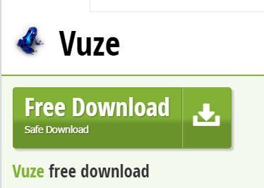



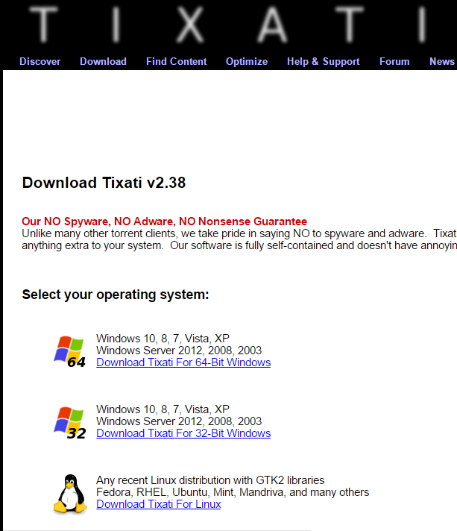

**So there you have it and yes I skipped number 4 on the list just so I could get to number five on the list Tixati the one I use now but the first one I used was UTorrent and it is number one so yes the number one torrent downloader was the one I used for many, many, many, many years. So I have never forgotten where I came from and I loved using it and it was a very easy format to use and I have not tried any of the other ones I mentioned except for Tixati and it is super easy to use as well. So I hope I have done a decent job educating you all and if you have any questions at all feel free to write to me and I will try and be as informative as I possibly can be so you all enjoy yourselves as much as I possibly have done for the past 12 years but my downloading has slowed way down now that I pretty much have everything from music to movies and software and yes there is new music that comes out I have to get and of course there is new movies that come out I have to get and there is a new one coming out called WarCraft June 10th that just looks plain awesome in the previews that is my next download. And you see I am always running Tixati so if there is anything I see that I want to download I already have it running so when I go to Kick Ass Torrents all I have to do is being I have all of my downloads saved to my desktop is click on download torrent and it puts the file on my desktop and being it is there it opens up in Tixati and starts downloading as soon as it finds the downloaders and uploaders to download it from and it normally goes quicker than you can say Wallah well maybe a little longer than that but you all get my idea right I am sure you will all have loads of fun. Hope to hear from you all. And finally before I forget here is a picture of BitChe the search software I told you about like Google.**

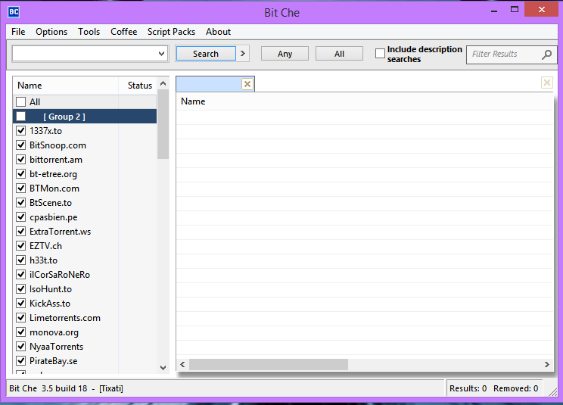

**And as you can see on the left side all of the torrent websites that is on the list and it is a pretty sufficient list of Torrent Websites just like I told you there is probably hundreds of sites to choose from. So enjoy and dont forget to write.**

**Vince Farmer**