**Wagon**

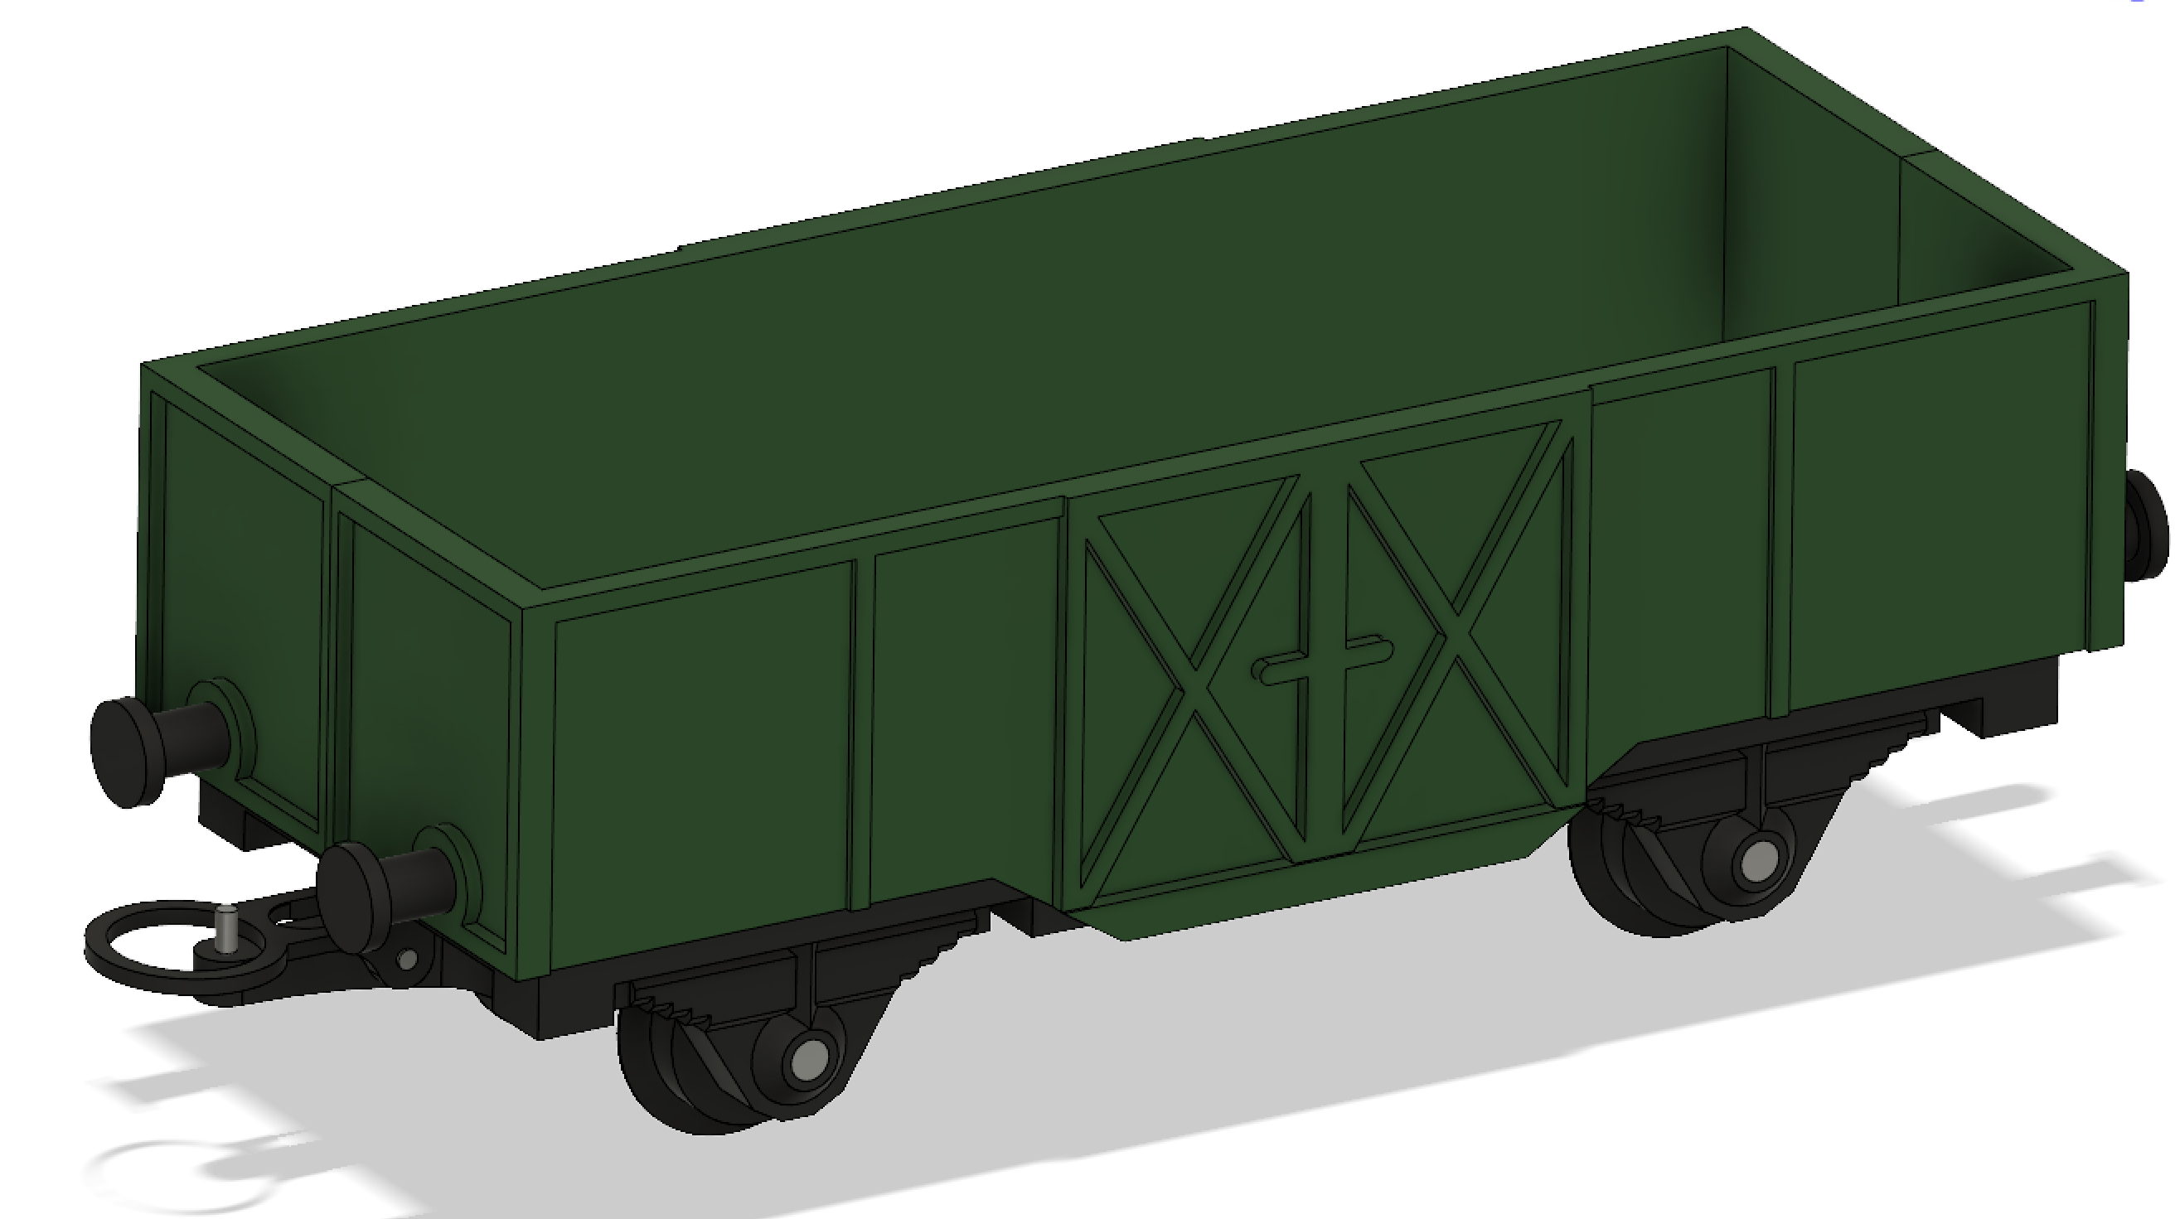

1. Print “Wagon3” with 3d printer.

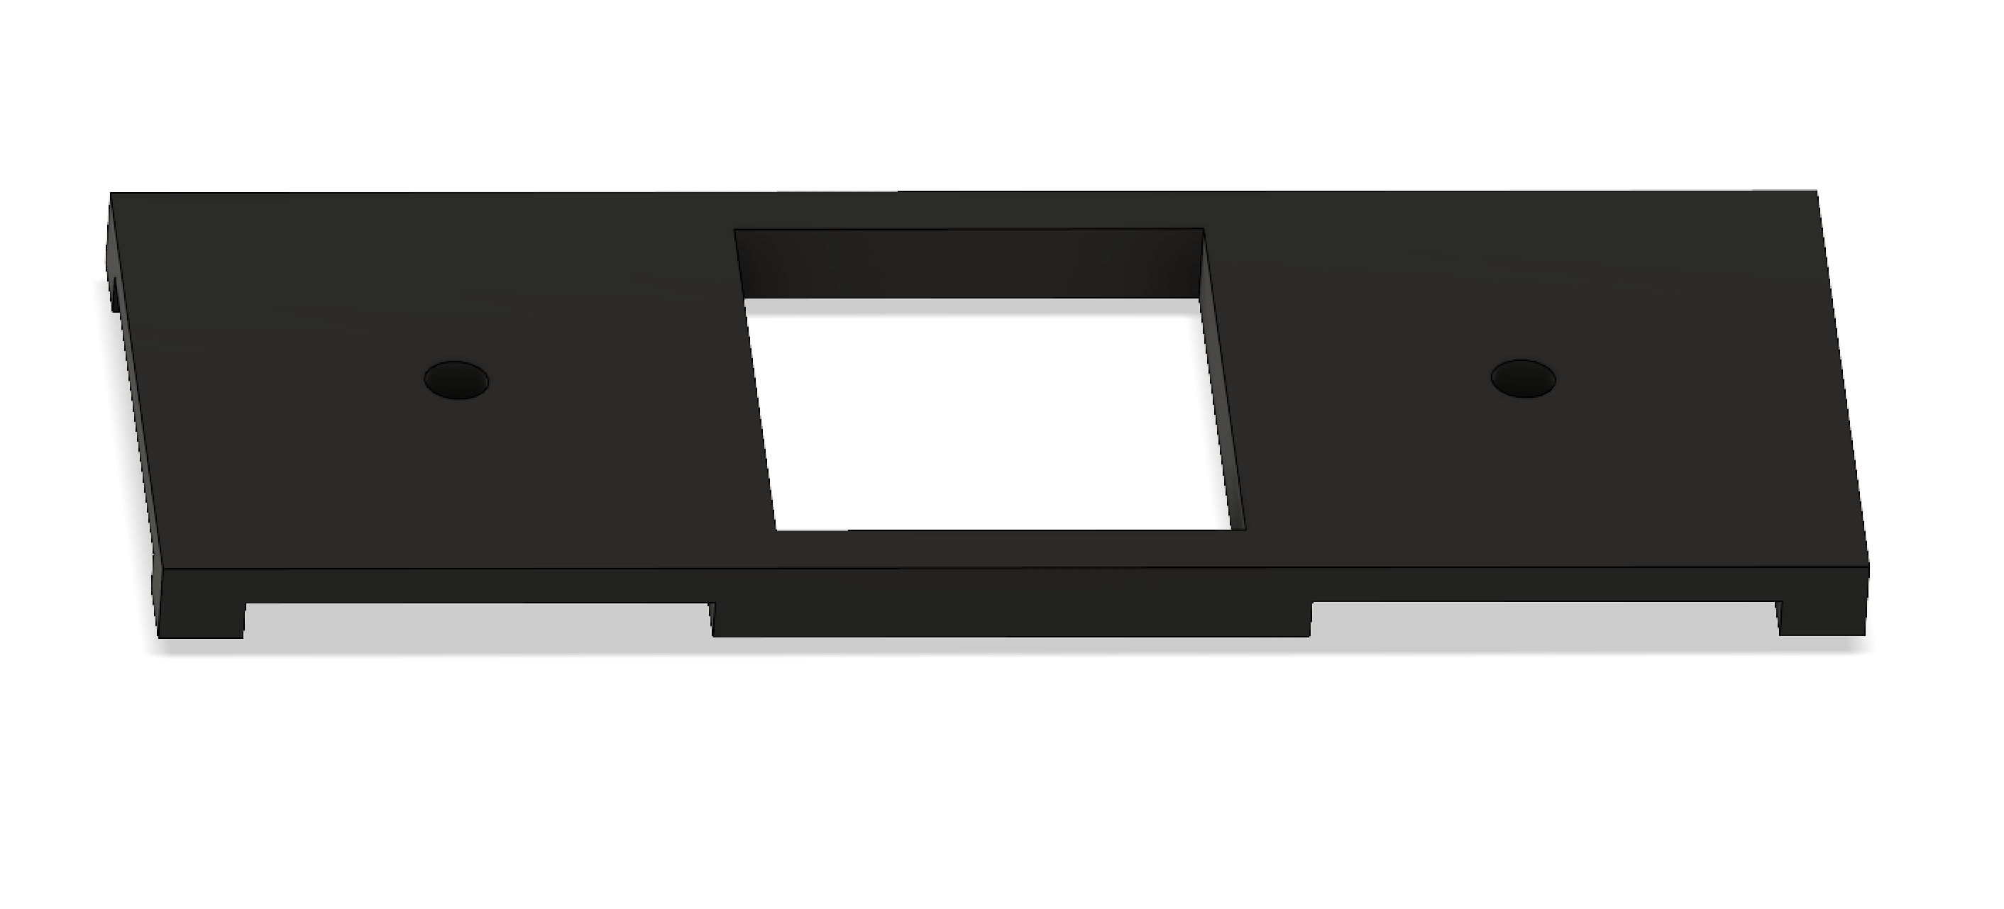

1. Print two pieces “Wagon2” and four pieces “Wagon1” with 3d printer.

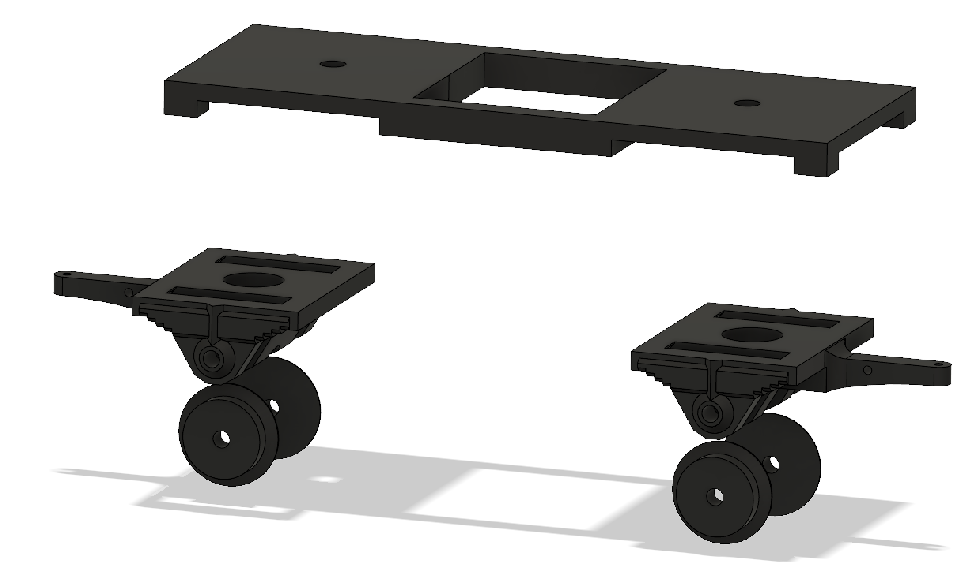

Cut nail (diameter 2mm, length 10mm) and put it in hole as you see on picture.

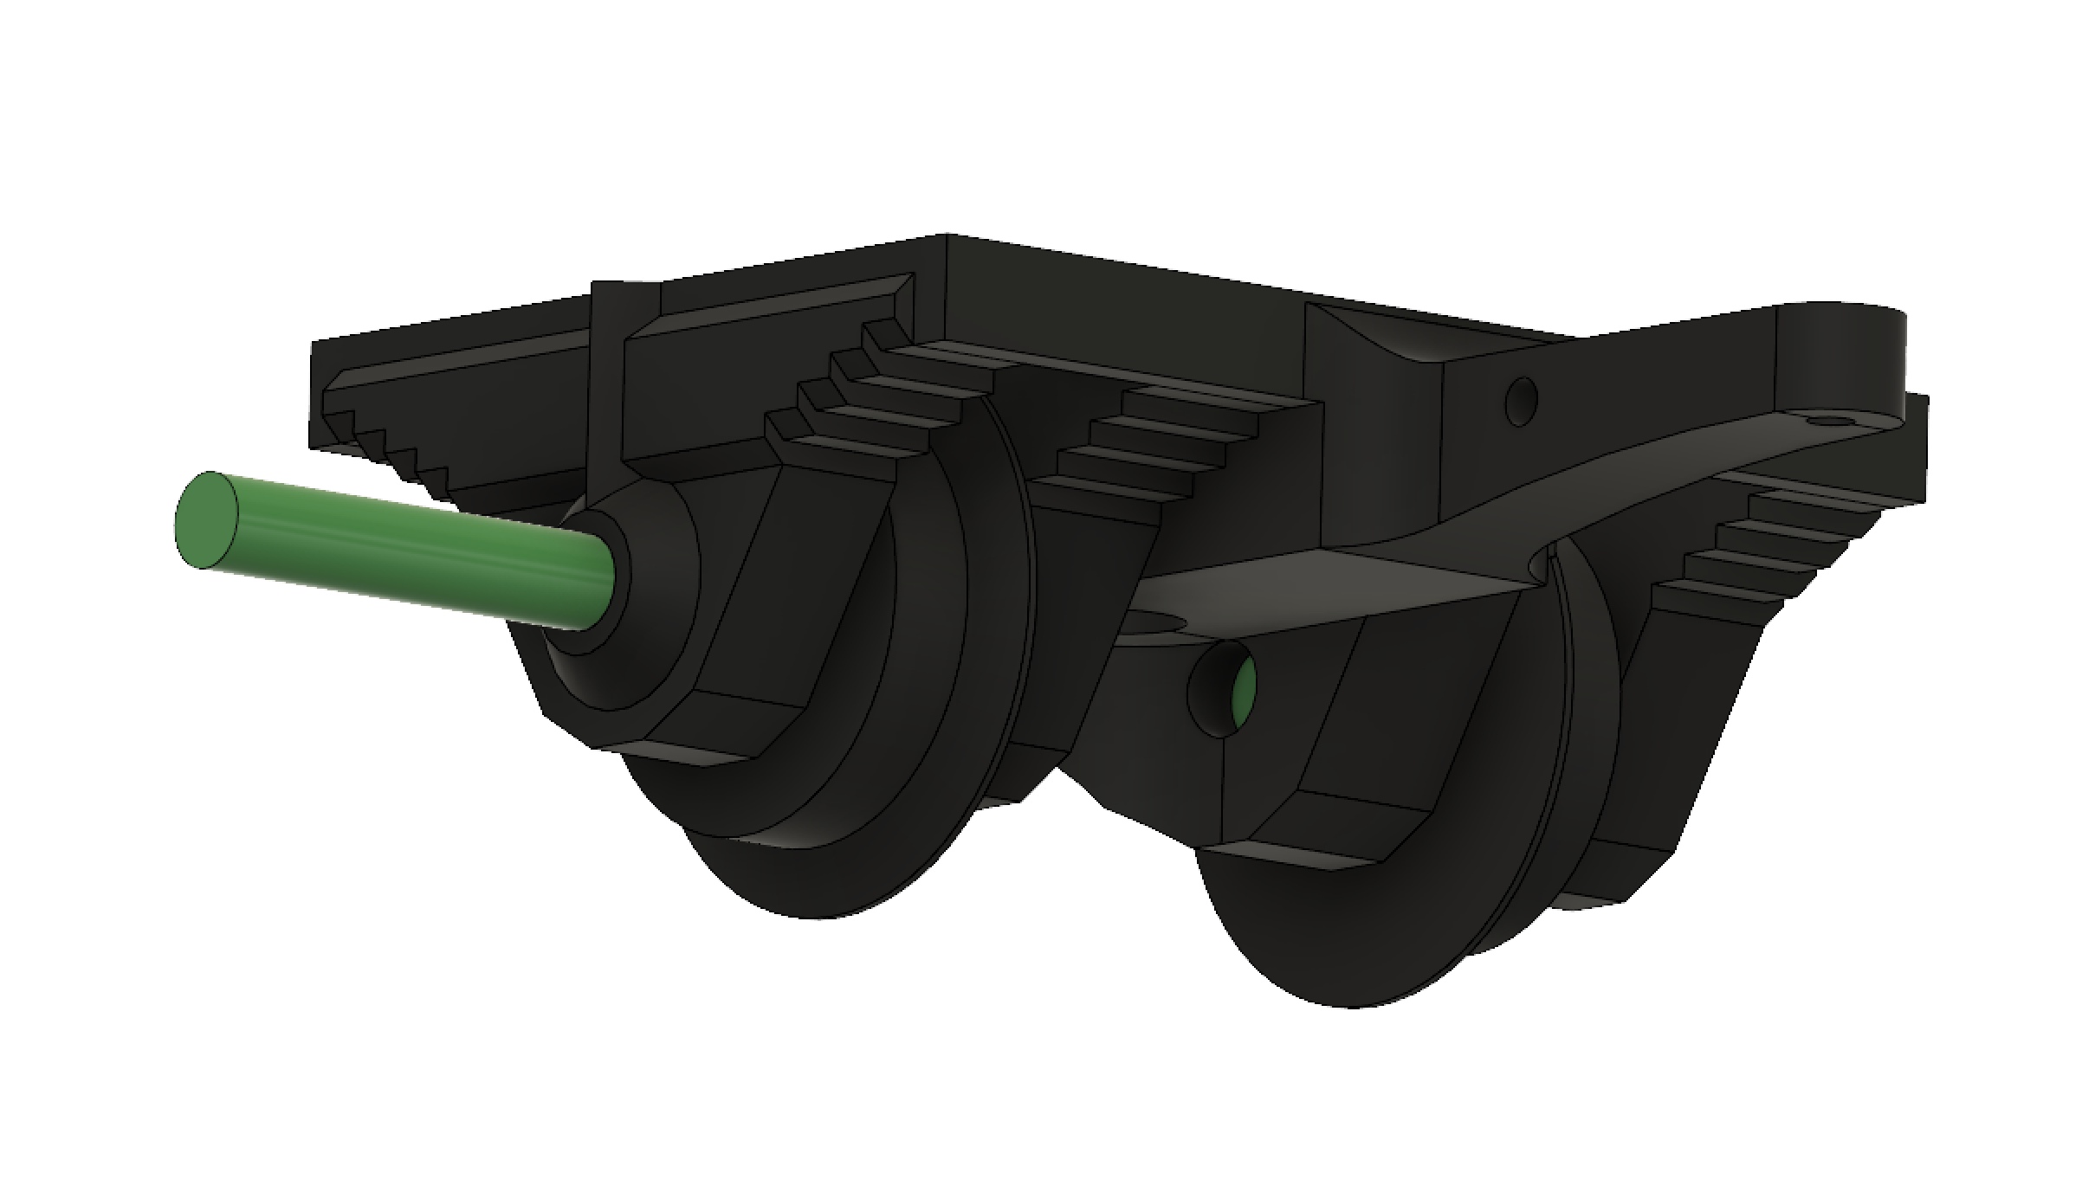

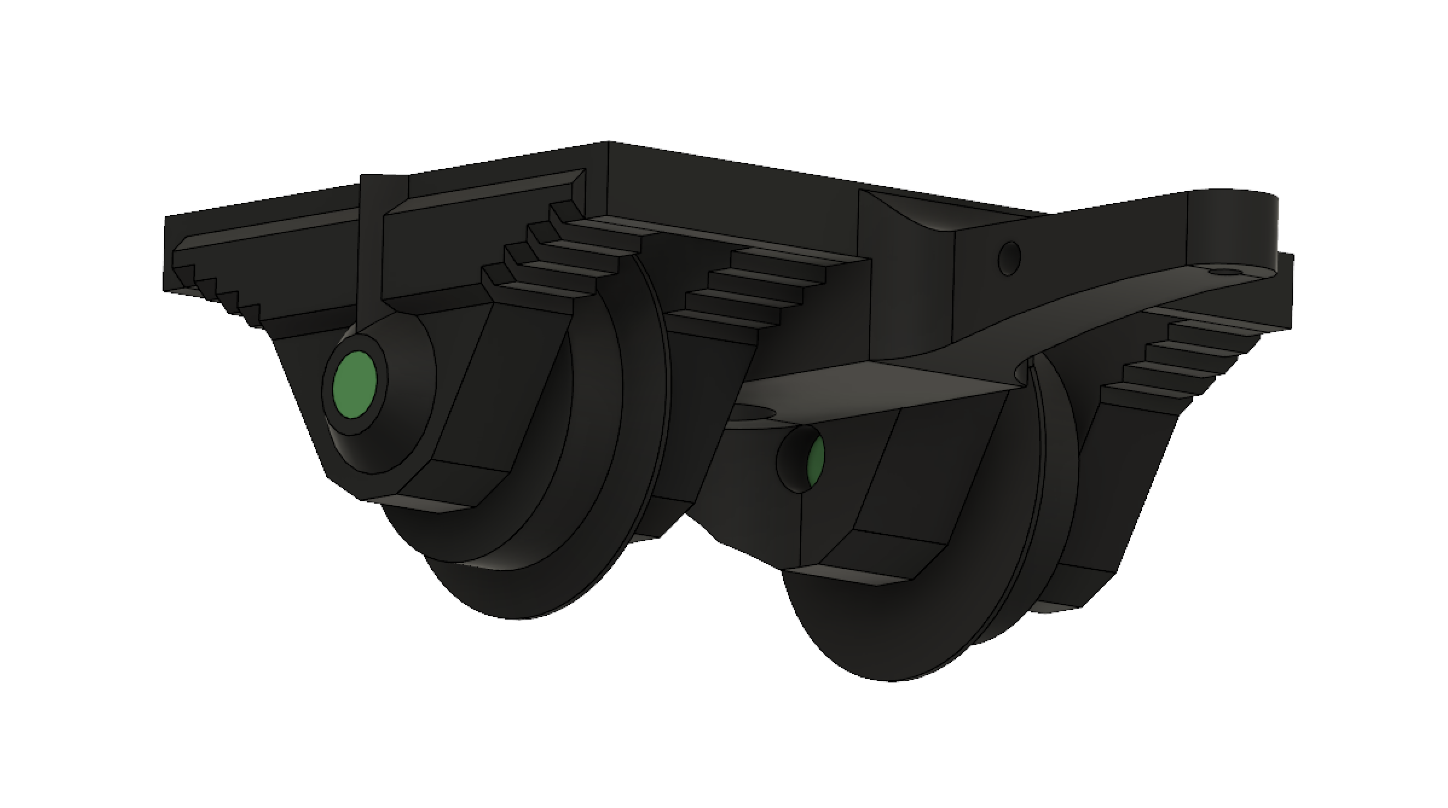

Do this on both parts and screw then on wagon frame with m3 screws.

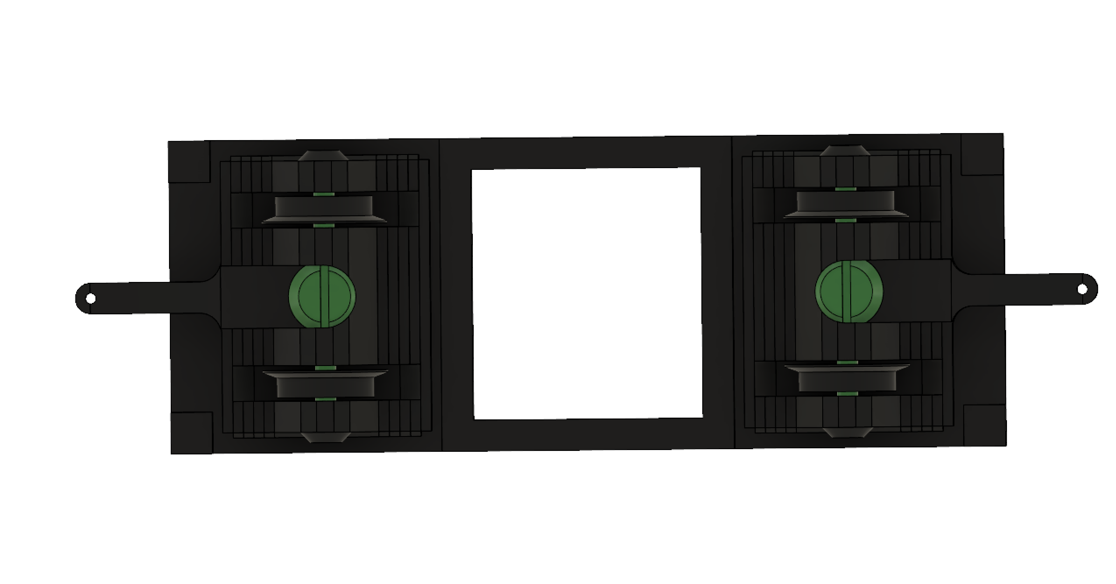

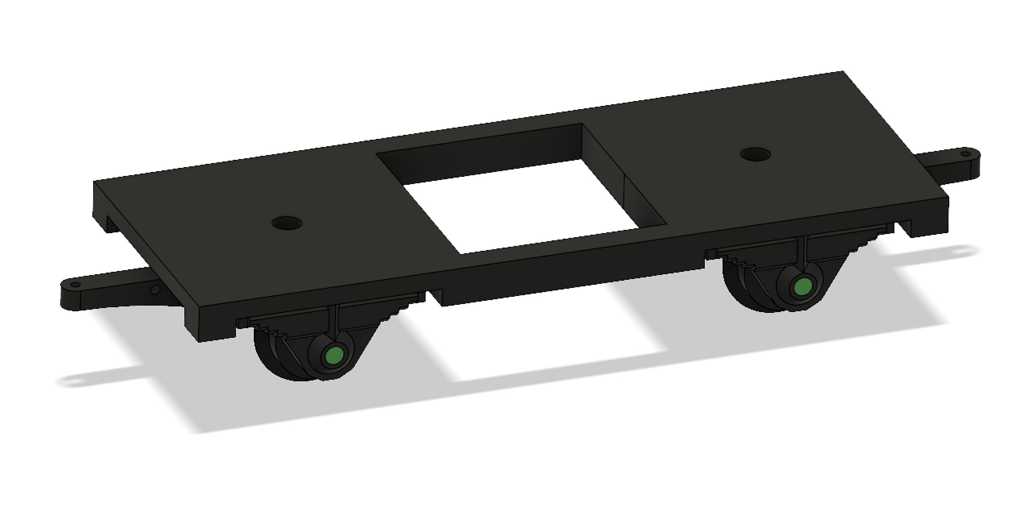

1. Print “Wagon5” and place it on wagons mainframe.

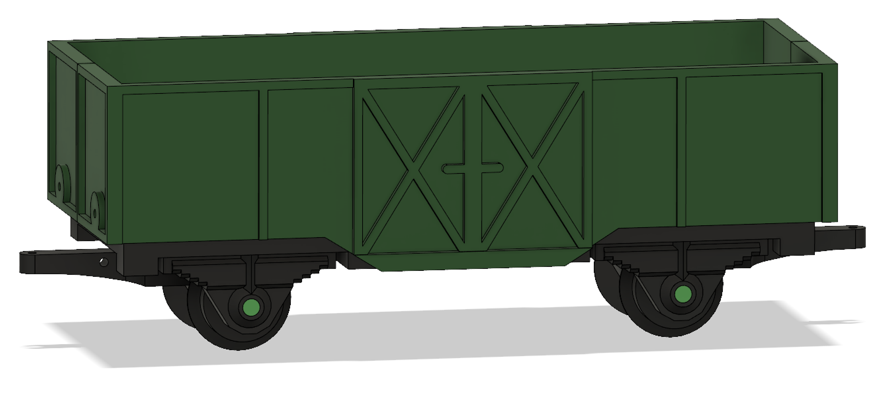

1. Print four pieces “Wagon4” with 3d printer. Cut 4 nails (diameter: 1mm, length: 6mm). Watch picture below.

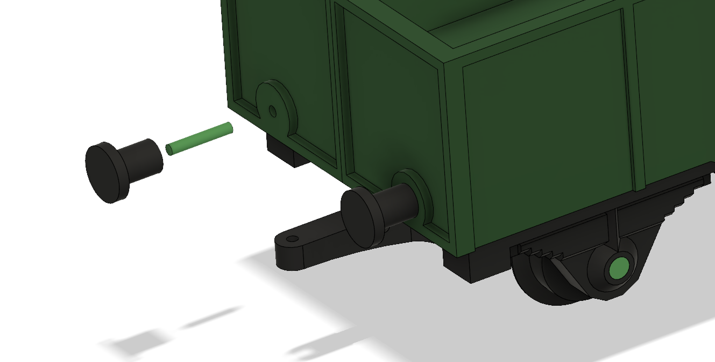

Do this on both sides.

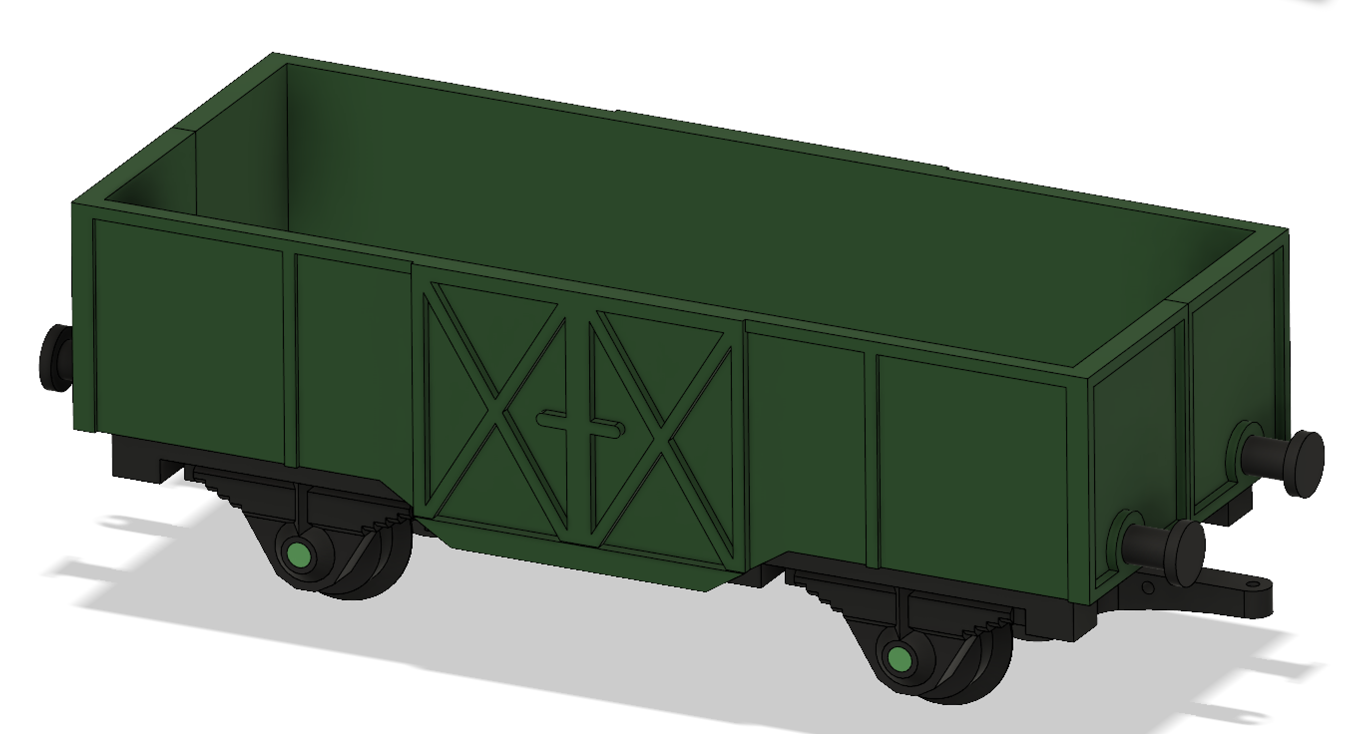

1. Cut two nails (diameter: 1mm, length: 4mm) and place them in holes as you see on picture.

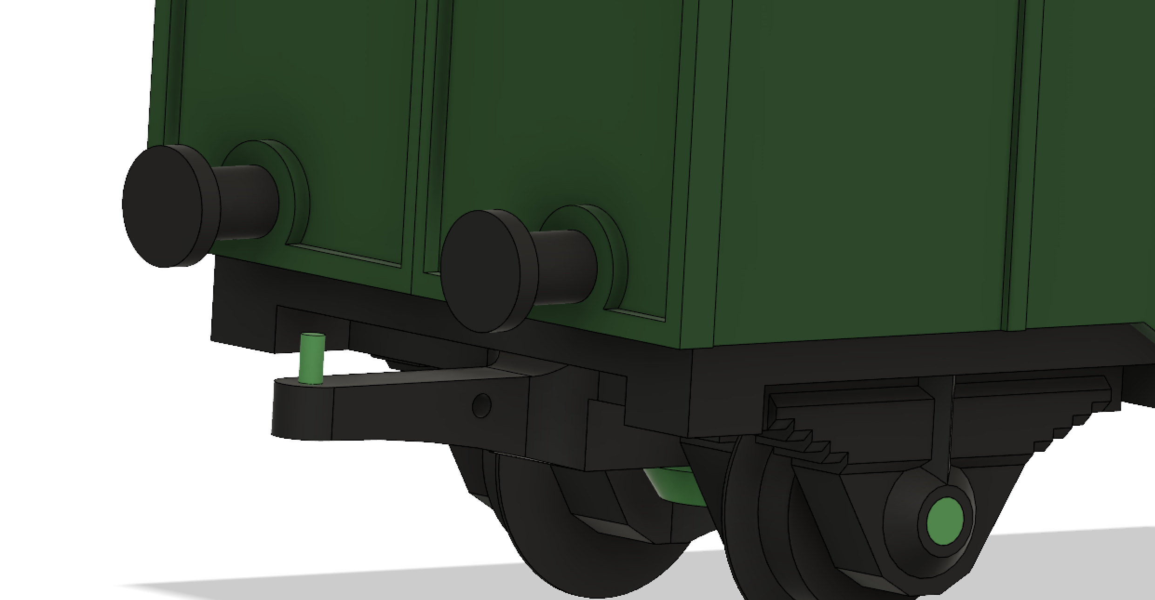

1. Print “Wagon6” and cut nail (diameter 1mm, length: 6mm). Watch picture below.

