Upgrading the RAM in your Desktop PC.

This instruction is intended for those with basic to moderate computer skills. If you do not know the difference between a desktop PC and Laptop, then this instruction is not for you.

Needed Tools:

1 - Cross tip or Philips screw driver.

Needed Materials:

New RAM

Can of Compressed Air

First you need to determine what RAM you can upgrade your computer to. You will want to know what Channel type, and Size you can use. There are two ways to determine what your system can use.

1. New PC Builds:

A new PC build is if you have to assemble the PC by installing all the components.

1. Upgrading an existing PC:

An existing computer build is usually one bought from a store or online that does not require any assemble.

I will cover each of these scenarios one at a time as to not confuse anything.

**New PC Builds**

1. Determine the type of RAM you need for your computer. You can do this by visiting the Manufacture of the Motherboard website. You will find the RAM specifics and type there.
2. Once you have determined and ordered the correct type RAM, you may also purchase the RAM from a local retailer, you can now install the RAM on your motherboard.
   1. ***\*NOTE* If you do not know what a motherboard is, this instruction is not for you. Installing RAM incorrectly into your PC will damage and destroy your PC.***
3. Once you have the RAM, you can install the on your motherboard. The following photos will assist in this step.

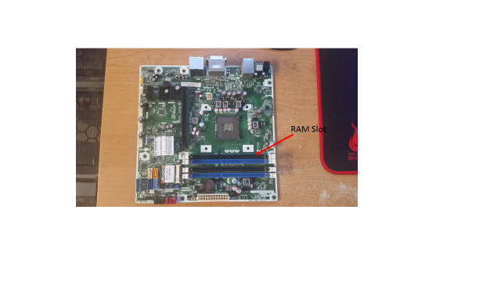

This is what the RAM slot on a motherboard looks like.

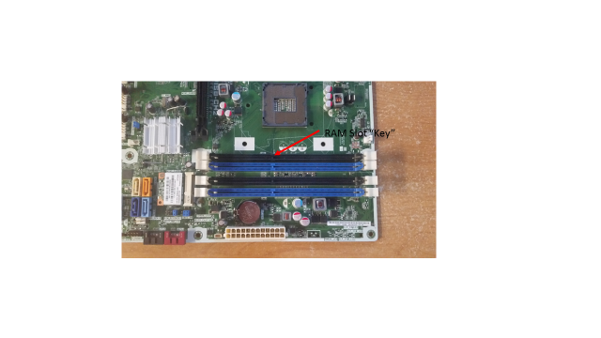

1. In order to set RAM in the slot, you will need to line up the RAM slot “key” and the key hole on the RAM chip. The next photo displays this.

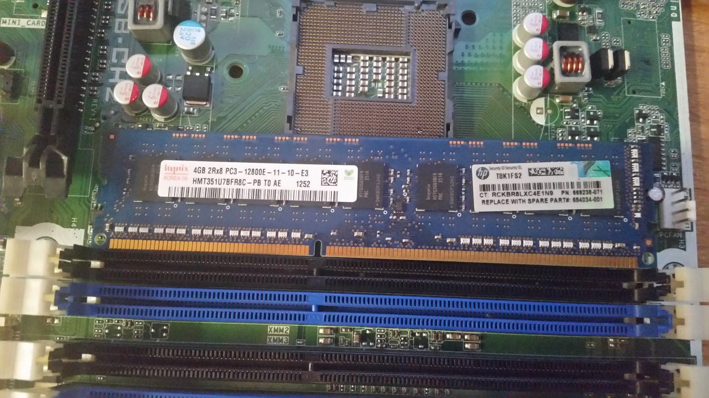

Line up Key with key slot on RAM chip

1. After you line up the key slot, you can set the RAM chip. The following photo illustrates this.

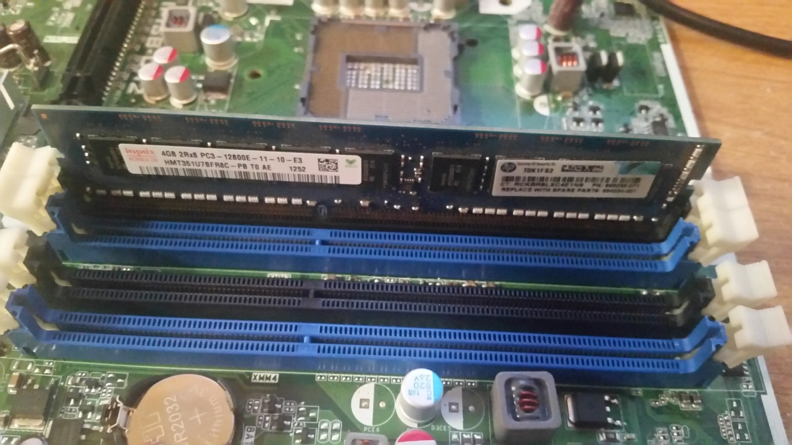

Motherboard RAM slot clips

1. After having set the set the RAM chip in place, you have to push in each side, you will have to push rather hard, to set the clips. Once the clips are set, this RAM chip has been installed.
2. Repeat steps 3 through 6 as needed for all RAM chips to be installed on your motherboard.

**Updating an Existing PC**

1. Determine the type of RAM you need for your computer. To do this, navigate to [www.crucial.com](http://www.crucial.com).



1. Once on this website, download and install the Crucial System Scanner. Once the system scanner is installed, run the system scanner.

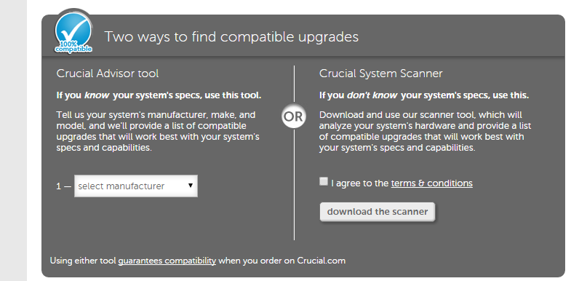

1. Once the scanner is installed, run the scanner on your system.

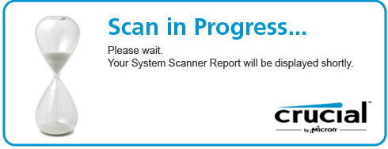

1. Once you have run the system scanner on your system, it will display the results on a web page. It will tell you the make and model of motherboard you are using, the maximum amount of RAM as well as what type of RAM you need.
2. Once you have determined and ordered the correct type RAM, you may also purchase the RAM from a local retailer, you can now install the RAM on your motherboard.
   1. ***\*NOTE* If you do not know what a motherboard is, this instruction is not for you. Installing RAM incorrectly into your PC will damage and destroy your PC.***
3. Once you have the RAM, you can install the on your motherboard. The following photos will assist in this step.



This is what the RAM slot on a motherboard looks like.



1. In order to set RAM in the slot, you will need to line up the RAM slot “key” and the key hole on the RAM chip. The next photo displays this.



Line up Key with key slot on RAM chip

1. After you line up the key slot, you can set the RAM chip. The following photo illustrates this.



Motherboard RAM slot clips

1. After having set the set the RAM chip in place, you have to push in each side, you will have to push rather hard, to set the clips. Once the clips are set, this RAM chip has been installed.
2. Repeat steps 3 through 6 as needed for all RAM chips to be installed on your motherboard.