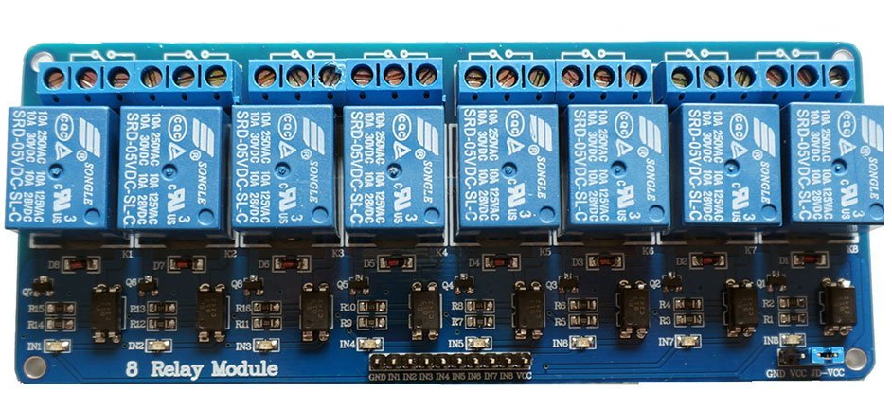

5 Volt Adapter

Remove blue jumper

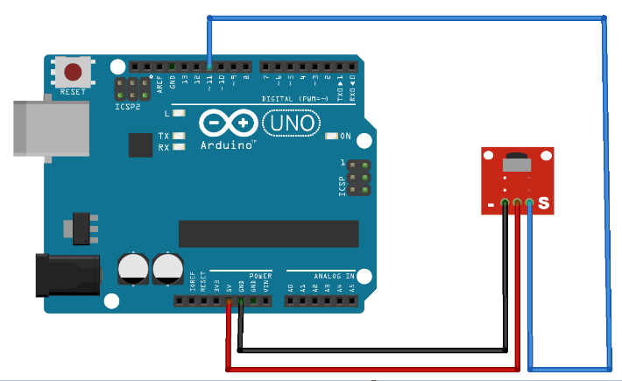

Then connect pin 2 - 9 from Arduino to pin in1 to in8 in relay module in series