**HOW TO MAKE A CHEESECAKE**

**Things you will need:**

1. Mixer
2. Large bowl
3. Teaspoon
4. ¼ cup
5. Cream cheese (2)
6. Graham cracker crust
7. Vanilla flavoring
8. Lemon juice
9. Condensed milk

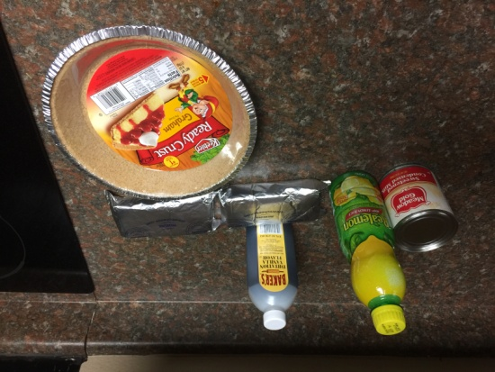 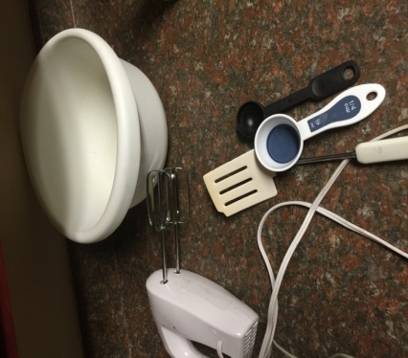

**Step 1**

Put cream cheese in large bowl; use mixer to mix

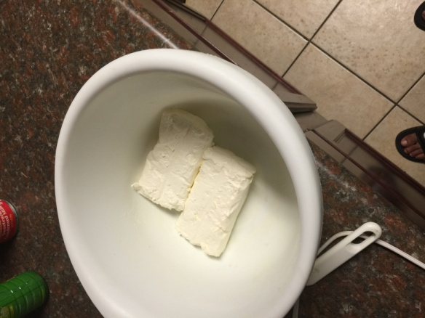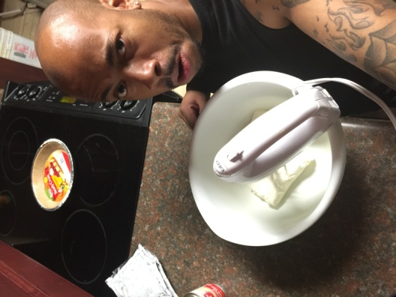

**Step 2**

Add can of condensed milk and mix until all cream cheese and milk are blended

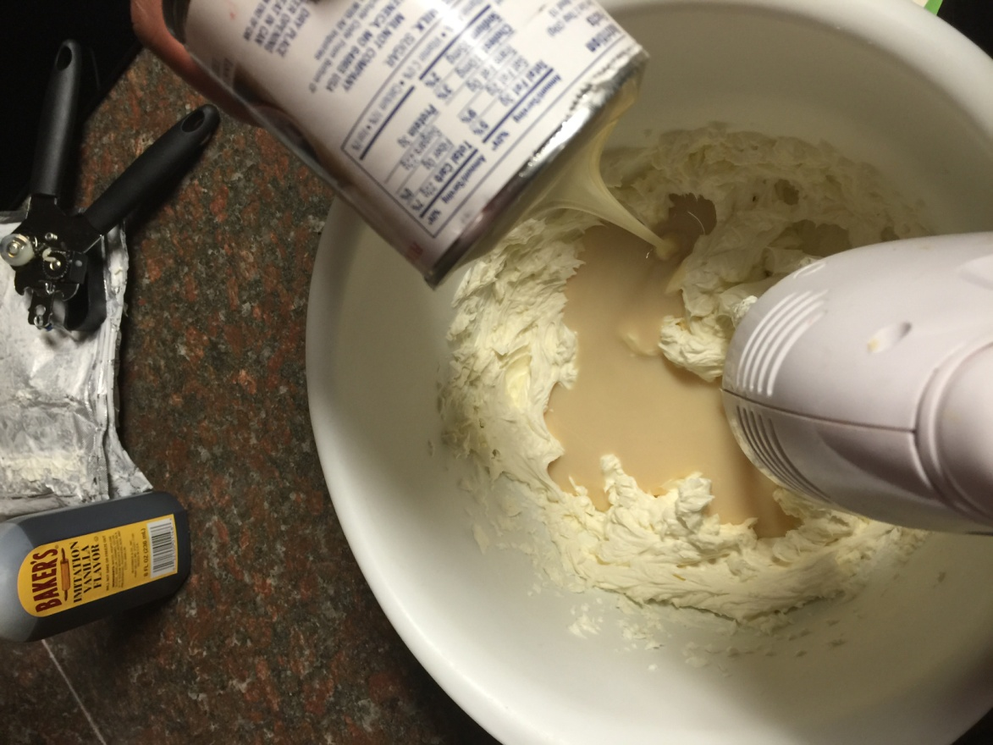

**Step 3**

Add ¼ lemon juice; mix until blended

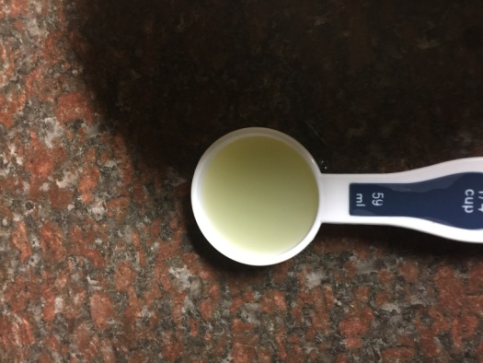 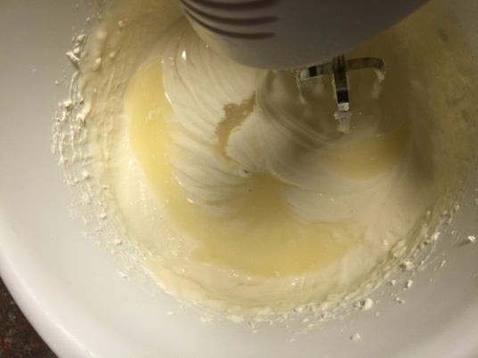

**Step 4**

Add 1 teaspoon of vanilla flavoring; mix until blended

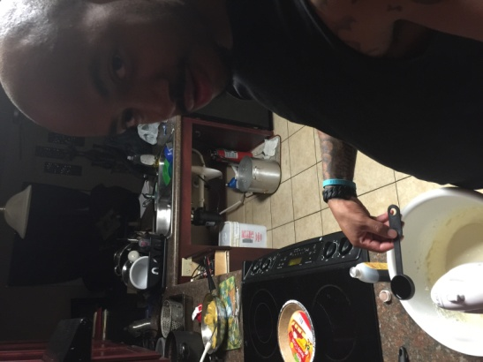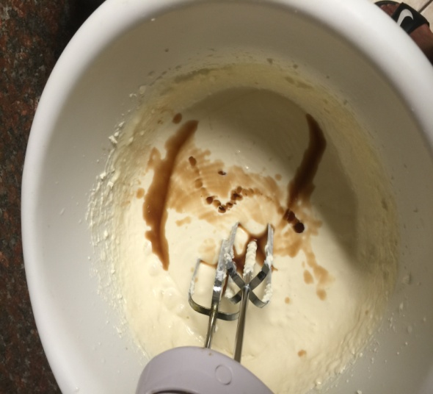

**Step 5**

Add finished product to graham cracker crust

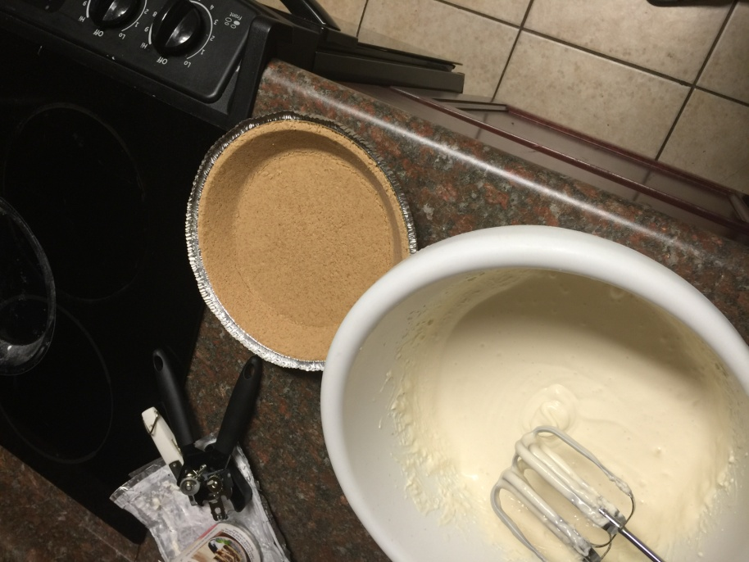

**Step 6**

Make sure cream cheese blend is evenly layered in graham cracker crust

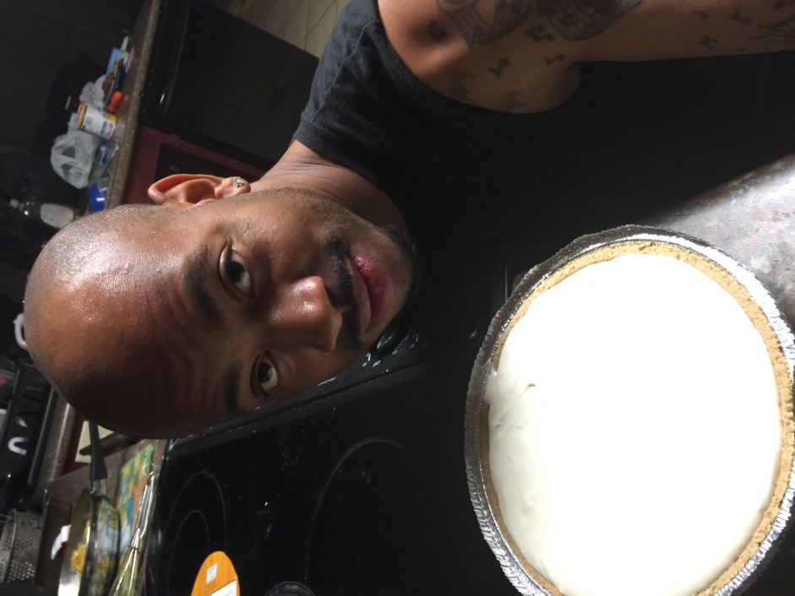

**Step 7**

Let cheese cake sit in refrigerator for at least 6 hour

**Step 8**

***Eat and enjoy!***