1- Download all the pieces (Note : All of the pieces were designed by our developer apart from the dragon as their mastery of the 3D software was deemed insufficient to obtain a piece meeting our minimal standard of quality.) :

Buildings : <https://www.thingiverse.com/thing:2841838>

Coin : <https://www.thingiverse.com/thing:2843482>

Viking Warrior : <https://www.thingiverse.com/thing:2841842>

Warlord : <https://www.thingiverse.com/thing:2841843>

Dragon : <https://www.thingiverse.com/thing:1624412>

Boat : <https://www.thingiverse.com/thing:2841850>

Sanctuary guardian : <https://www.thingiverse.com/thing:2843497>

Flag : <https://www.thingiverse.com/thing:2848686>

2 - Upload the pieces into a 3D software (Recommended : Simplify 3D) to export them into.stl files. Be sure to adjust the weight, height and depth of your so that it fits on the board's tile.

3 - Print your pieces using a 3D printer :

- The print may have to be redone as it may fail numerous time.

- Vary the settings to optimize the quality of your print (%infill, adding support, adding raft, heat, material etc...)

Tip and trick : PLA and ABS are good/simple materials.

4 - Peel off the support and the raft if needed. Be careful and use any tool that are deemed necessary. Tip and trick: Use tweezers for a better precision.

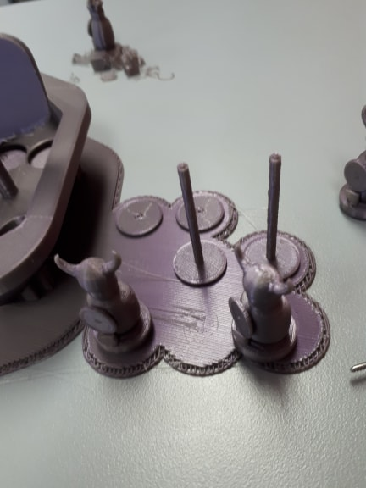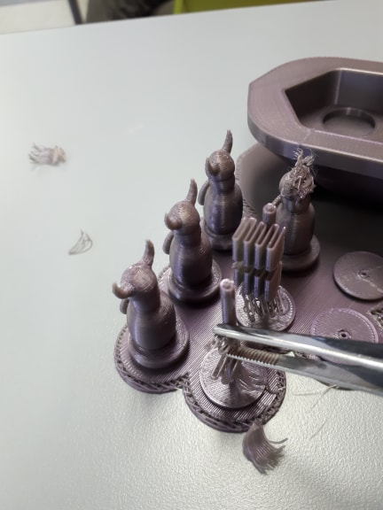

5 - Assemble pieces if necessary :

Boat :

1. 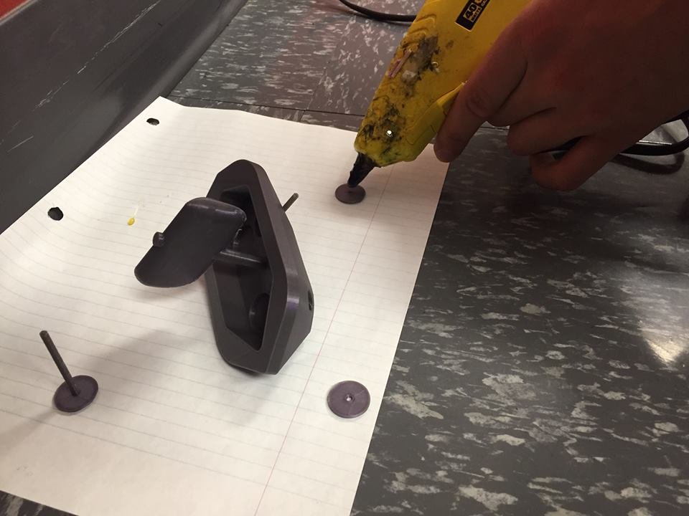Put the boat on the side and pass the axle with the combined wheel into the hole.
2. Hot glue the separated wheel onto the axle.

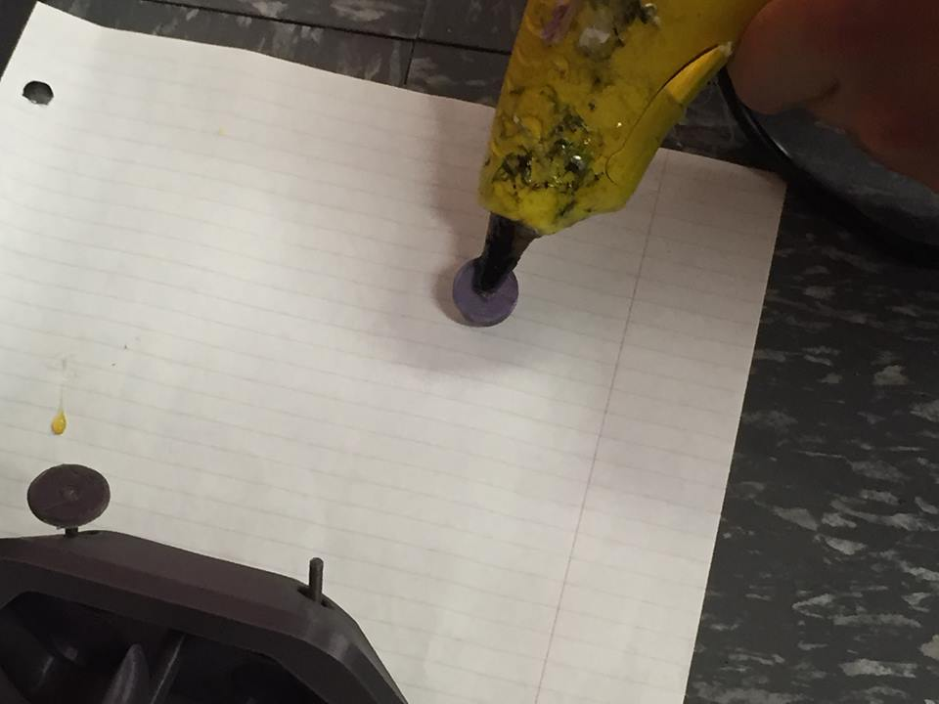

1. 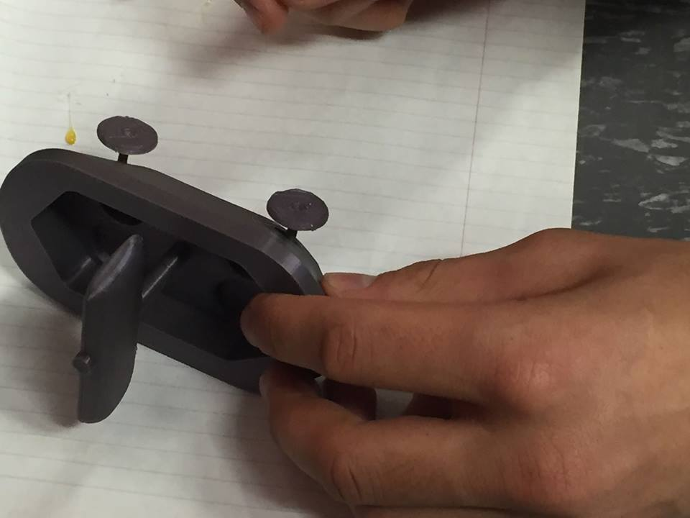Wait 15 minutes for the hot glue to solidify.

6 - Use the pieces according to their designed usage.