Wiring info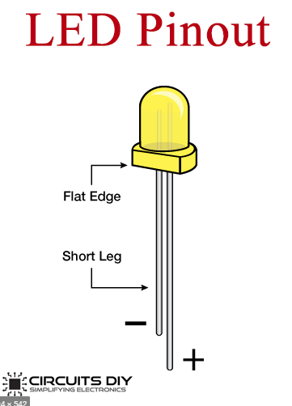

Leds are connected to the arduino in pairs so that two light up from each assigned pin. The order goes as such:

PIN 49: LED group 1

PIN 50: LED group 2

PIN 51: LED group 3

.

.

(this goes on until PIN 42)

.

.

PIN 43: LED group 7

PIN 42: LED group 8

The negative side (shorter wire) of the LEDs go to ground

The single RGB LED is wired as such:

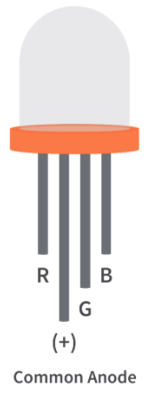

PIN 36: R

PIN 35: G

PIN 34: B

The longest pin of the RGB LED is connected to 5V on the Arduino.

The + end of the small speaker will be connected to PIN 18 of the Arduino, and the other end goes to ground.

The banana plug is connected to a 9V battery for power.

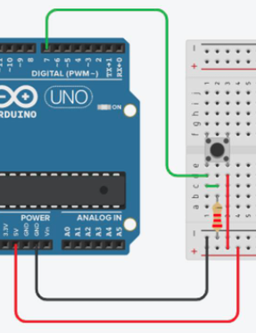

The pushbutton is connected to pin 25 of the arduino and ground

(reference for how it is set up to the right)