Apoorv Wairagade

awairaga@purdue.edu

Project 2

ENGL 421

# INSTRUCTIONS TO INSTALL LINUX

This instruction manual is guide to install Ubuntu 14.04 on a computer with or without an operation system installed on it. However, the computer motherboard should have a preloaded BIOS installed on it, most computer have it installed so this should not be a problem. This instructional also goes through making a bootable flash drive in case the user does not have a CD for the Ubuntu OS to be installed.

# MATERIALS:

1. USB Drive
2. Internet connection
3. Any Personal Computer to install Ubuntu
4. Computer with any fully functional operating system on it.

# Instructions:

## STEP 1:

Plug in the USB drive into the working computer

Back up the data on the USB to the computer

Right click on the USB Folder and Format it. This will **ERASE EVERYTHING** on the drive, so make sure, data is backed up.

## STEP 2:

Download the latest version Ubuntu from the working computer with the internet connection. The link for the download is below.

<http://www.ubuntu.com/download/desktop>

Select the Ubuntu 14.04 version since it is the more stable version out there. But you can also go for the latest 15.10 version. This tutorial covers Ubuntu 14.04 .

Clicking on the version will take you to a donation page. You can chose either to make a donation, (since Ubuntu is free) or skip and go ahead to the download page.

## STEP 3:

In this step we will make a USB flash drive bootable so that the OS can be installed on the new machine. To do this a safe free online software needs to be downloaded.

Make the USB bootable by using the software available on the website <https://rufus.akeo.ie/>

Once downloaded, start the software and enter the following information as shown.

*Device*: Select the Flash drive from the drop down menu here

*Partition*: GPT partition scheme

*File System*: FAT32 (This is important, else the installation won’t work)

*Cluster size*: default (8192 bytes)

*New Volume label*: (new name for the drive, doesn’t matter what it is)

Check all the boxes other than the first one. This includes Quick Format, Create a bootable disk using ISO image, Create extended label and icon files.

And then press start.

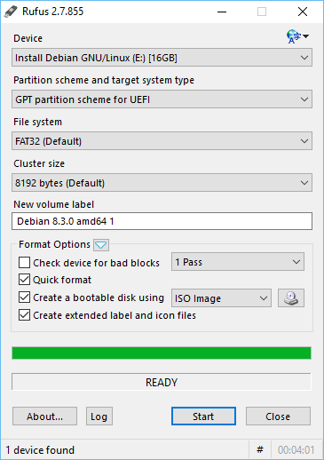

## STEP 4:

Once the USB is bootable, insert the USB in computer where Ubuntu needs to be installed.

Access the BIOS setting of the computer by pressing F12 during boot up. This will show a menu like in the picture below. Use arrows to navigate to the “Boot device select” option.

Change Boot Device to USB.

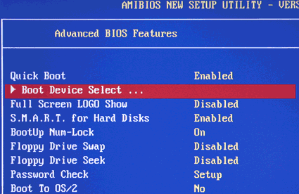

Press ESC to exit BIOS.

Once Exited out of the BIOS. Ubuntu install should start.

## STEP 5:

Follow on screen instructions. Select English or any other preferred language and select Install Ubuntu.

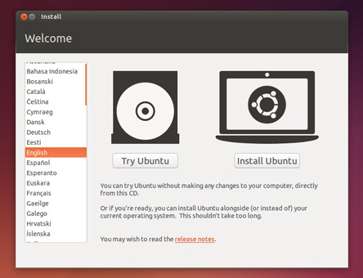

## STEP 6:

Check both the option boxes and click continue.

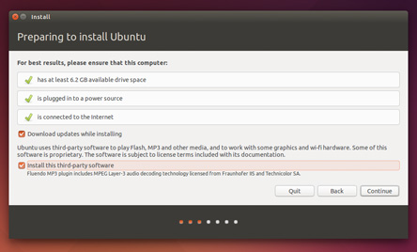

## STEP 7:

This is where you can select if you want to overwrite the current operating system or keep both at the same time.

Keeping both at the same time can slow the computer down, while overwriting will remove the existing OS.

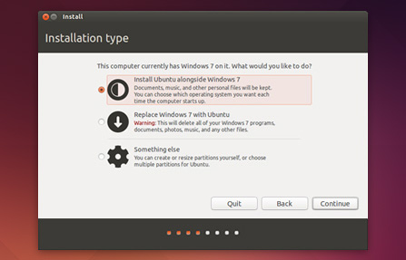

## STEP 8:

Press Continue, the installation of Ubuntu 14.04 will start and you should be brought to this screen (with the install progress bar).

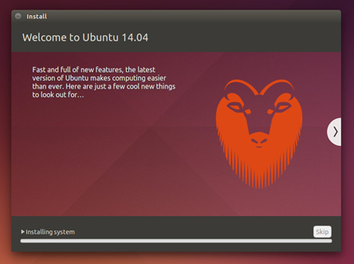

## STEP 9:

After the installation is complete Just restart your computer on which Ubuntu is being installed by pressing the “Restart Now” button. Once the computer starts, Ubuntu will boot up.

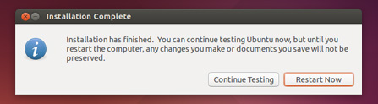

## CONCLUSION

Now that Ubuntu is installed you should be able to use the various features of Linux operating systems. A good place to start would be “Ubuntu Software Centre”. Here you can find many popular apps ready to install. You can also install third party apps which are not in the store but that is a little harder and “Terminal” has to be used. Happy exploring!