**How to make a simple breadboard at home**

**T**his article describes how to make a simple low cost breadboard .you can build an electronic circuit on a bread board without any soldering .best of all it is reusable. This simple breadboard makes it easy to use for creating temporary prototype and experimenting with circuit design .The interesting thing behind this project is that you can build it at home by using easily available parts. The problem with this model is you cannot use ICs .

Materials required for this project is listed below and shown in fig.1:

1. Aluminium foil

2. Foam

3. Adhesive (like fevicol)

4. Utility knife

5. Scissors

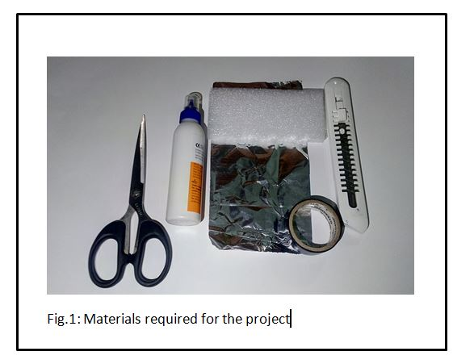

**Construction and testing:**

**Step .1:** cut the foam in half by using a utility knife as shown in fig.2.

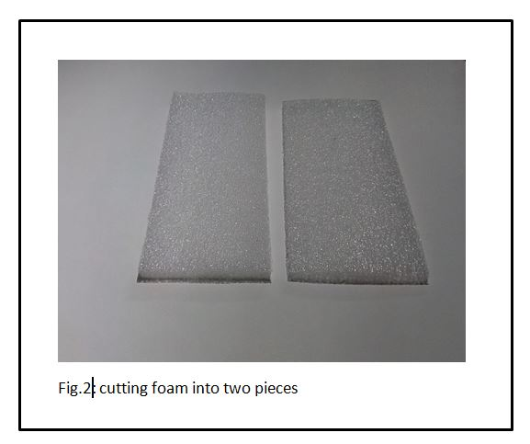

**Step.2:** cut aluminium foil by using a scissors according to the prototype model shown in fig.3.

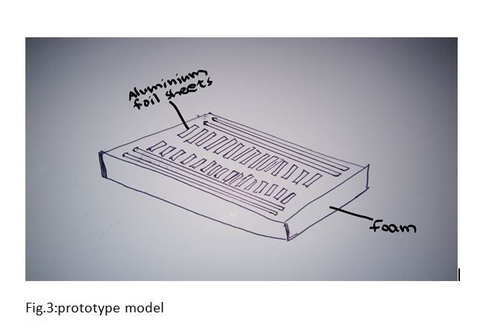

Stick aluminium foil pieces in to the foam (fig.4) by using adhesive.

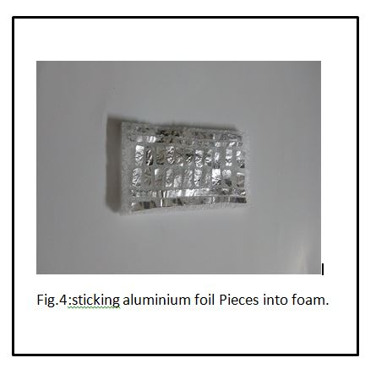

**Step.3:** A simple circuit diagram for testing the prototype is shown below

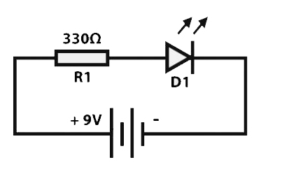

Place the electronic components as per the circuit diagram

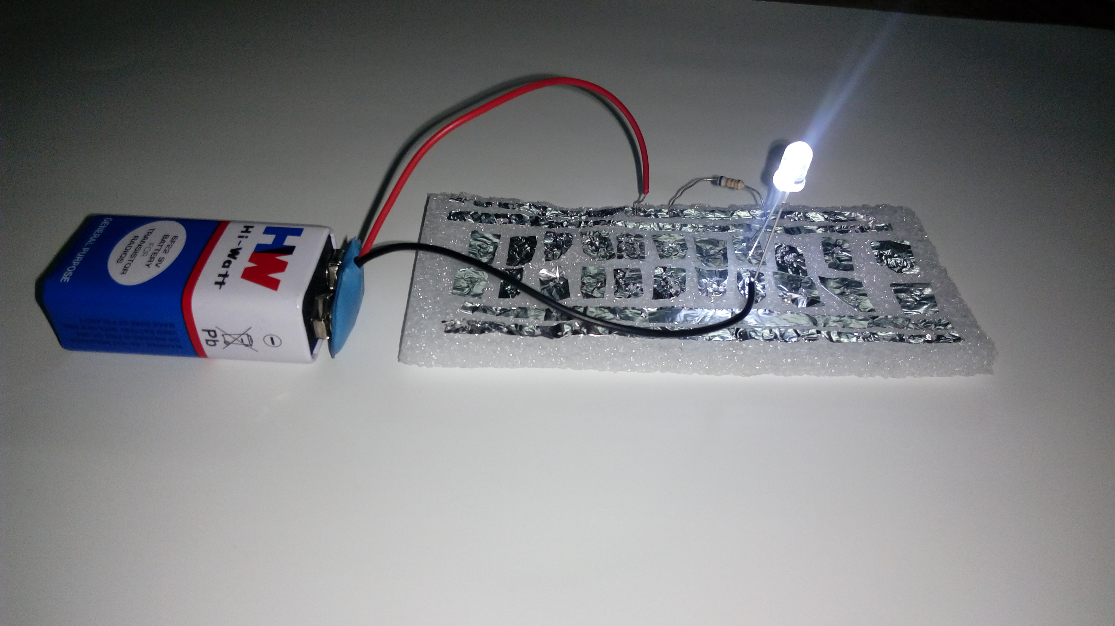

You have successfully made a homemade low cost bread board.