**Cut and Fold Face shield**

**Here is the link of the site I made if you wanted to share my design:** [**https://sites.google.com/ust.edu.ph/cutandfoldfaceshielddanieldc/home**](https://sites.google.com/ust.edu.ph/cutandfoldfaceshielddanieldc/home)

**What you’ll need:**

1. Glue*

2. Carboard*

2. Printing paper, preferably 220-300 gsm

*Optional only (You can also use any coupon bond paper but you will need to paste the cut-out into a thicker paper like cardboard/ thick/glossy paper bag/ folder/ shoebox or any paper sturdy yet flexible enough to fold)

3. Scissors

**Directions:**

I. Print the Cut and Fold Face Shield, which can be downloaded here:

<https://drive.google.com/file/d/16lcb_nP_KrEMseyAkup4c01CZWOhU_Gu/view?usp=sharing>

! **DO NOT CUT THE MARGIN.** I tried my best to fit the cut-out without the margin but I have not resolve it yet. Don’t worry, just follow the directions and enjoy.

**II. Cut and fold**

Cut along the **solid/Dark/Bold lines** and fold along the broken/dotted lines. Also, if your printer have margin, DO NOT CUT ALONG THE MARGIN and cut it as it is following the **Solid/Dark/Bold lines**.

**III. Assemble the parts**

For the Face shield

a. Join **1** and **2**. Make sure you cut the **Solid/Dark/Bold lines** found on both the flaps which will serve as the slit.

b. Push the two slit together and make sure that the slit on **2**, is thoroughly push down against the slit on 1. Make sure that they are lock together nicely. See Figure **1.1.**

c. Repeat the process for **3**, instead of using **2**, you will now use the slit on the **3**.

For the face shield holder

a. Make sure you cut along the two (2) **Solid/Dark/Bold lines** on the face mask holder as you will need both of them.

b. Push one slit on the face shield holder on the slit found on between the upper **4** and **5.**  Make sure that they are lock together nicely. See figure **1.2**.

c. Repeat the process for the other face shield holder, instead of using the slit found between the upper **4** and **5**, use the slit found on between the upper **6** and **7**.

d. Push the slit together found on each end of the face shield holder. Try to fit to your size prior to attaching to the slits on each end of the face shield holder. Make sure that they are lock together nicely. See figure **1.3**.

It’s finished see **Figure 1.4** on the third page for the picture of the finish product of CUT AND FOLD FACE SHIELD.

You can now use your Cut and Fold Face shield to fight Covid19. Make sure to always wear a mask whenever you go outside.

Disclaimer: This face shield is for single use only, and it is not recommended as substitute for PPE(Personal Protective Equipments). Dispose it with care immediately after use.

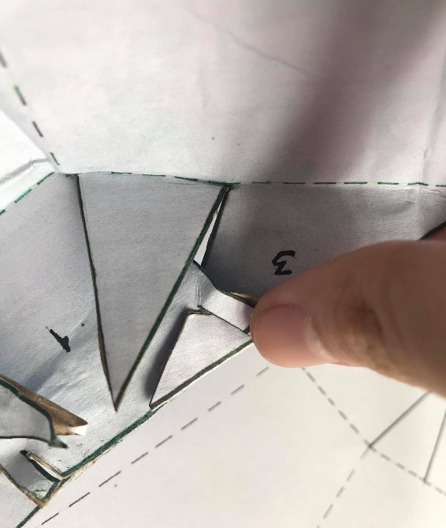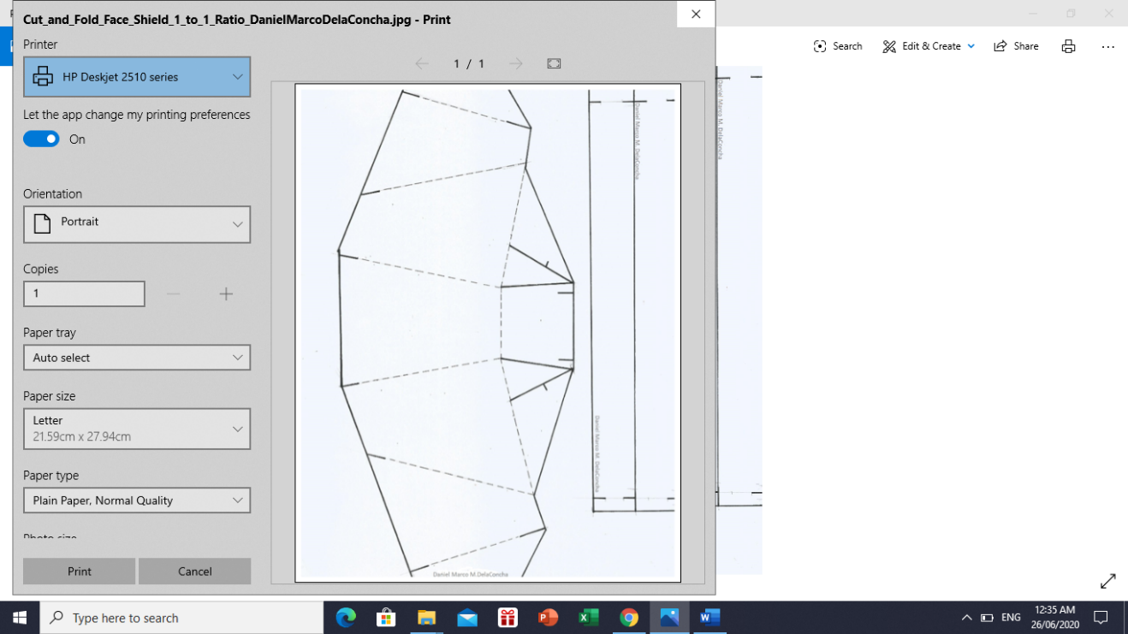

**Figure 1.0**

Margin

Margin

**Figure 1.1**

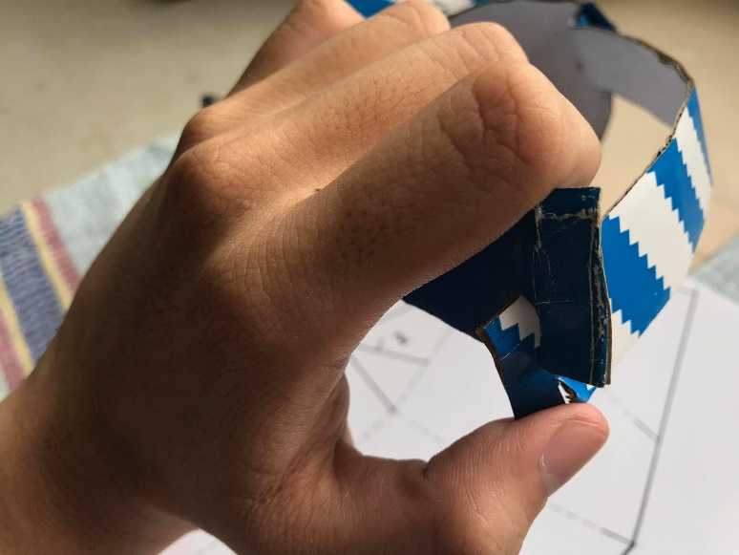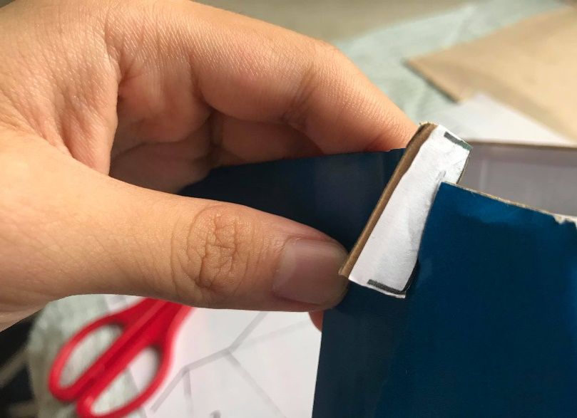

**Figure 1.3**

**Figure 1.2**

Finished Product

**Figure 1.4**

