**International Design Project 2016**

**Team D**

**BB-8 Robot**

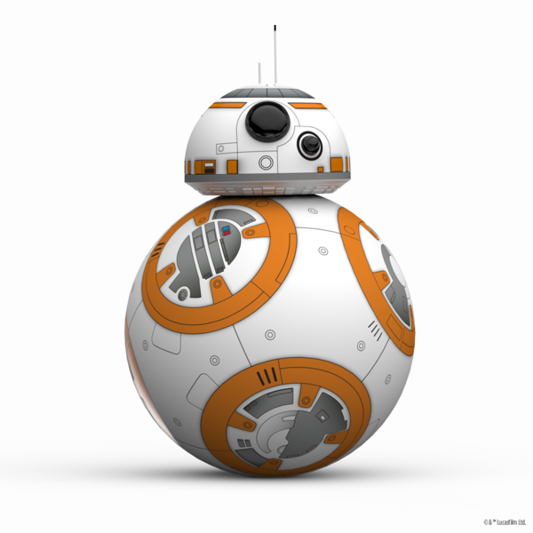

**Sketches of BB-8**

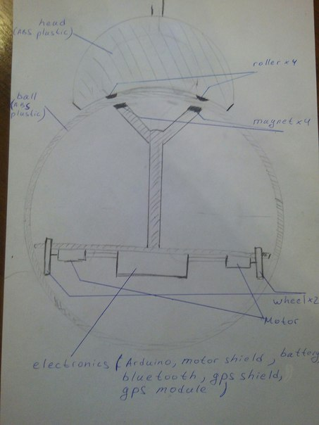

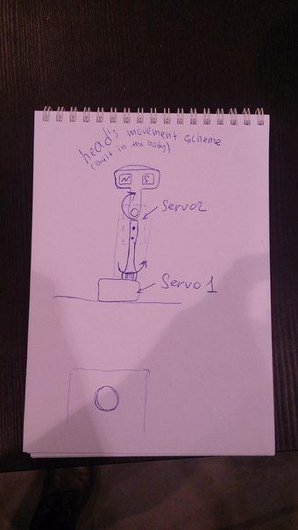

**List of materials and electronics**

|  |  |  |  |
| --- | --- | --- | --- |
| **Item** | **Quantity** | **Price (RUB//EUR)** | **Link** |
| DC motor | 2 | 200//2,64 | <http://roboparts.ru/products/tt-motor> |
| Servo motor | 2 | 600//7,93 | <http://roboparts.ru/products/category/248432> |
| driver for motors | 1 |  |  |
| GPS module | 1 | 908,28//12 | <http://www.amazon.de/niceeshop-Aircraft-Flight-Controller-Schwarz/dp/B00S4RLICU/ref=sr_1_1?ie=UTF8&qid=1458767247&sr=8-1&keywords=GY-GPS6MV2#productDetails> |
| Battery | 1 |  |  |
| Wheels | 2 |  | Can be 3 D Printed |
| ABS plastic |  |  | For 3D Printer |
| Plywood |  |  | In stock |
| Magnets | 8 | 120//1,58 | <http://magnet-prof.ru/index.php/Disk-/-Sterzhen/Neodimovyiy-magnit-D16x10-mm.-N33/flypage.tpl.html> |
| Bearing |  |  | <http://www.tehburo.ru/> |
| Raspberry pi 3 includes Wlan and Bluthooth | 1 | 3406,05//45 | http://www.amazon.de/Raspberry-Pi-quad-core-Wifi-Bluetooth/dp/B01CEG24WO/ref=sr_1_1?ie=UTF8&qid=1458767403&sr=8-1&keywords=raspberry+pi+3 |

**Total: 5234,33 RUB or 69,15 EUR**

**Timetable**

|  |  |  |  |  |  |  |
| --- | --- | --- | --- | --- | --- | --- |
|  | **Mo** | **Tu** | **We** | **Th** | **Fr** | **Sa** |
| **Svenja** | head modelling | Assembly work and development build | | | Final assembly and testing | Final testing |
| **Shen** |
| **Moritz** | Electronic modelling | Programming | | |
| **Polina** | Inside body parts modelling | Assembly work and development build | | |
| **Petr** |
| **David** | Parachute system | etching | Assembly work and development build | |

Modelling (including the part before school): ~2-3 days

Printing the body: ~one night

Assembly work (including mechanical and electronic parts assembly and time for mistakes): ~3-5 days