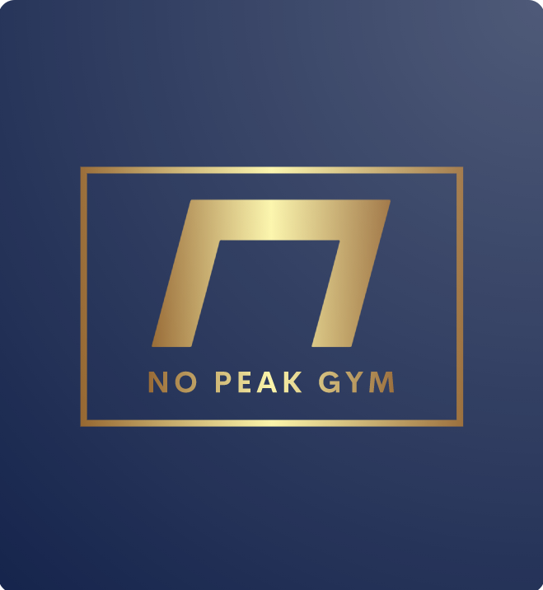

Registered Nurses, X-Ray Technicians, Certified Physicians and Therapists

Legal Consultation for NCAA /Professional Athletes

Diverse assortment of training staff and training equipment

Gender-inclusive

Mental Health Resources

Spa-like, Leisurely atmosphere

Community focused leadership

Total Body Rehabilitation

Layout structured around COVID-19

Suited for Professional and Recreational Athletes

Spacious exterior, conforms to natural landscape

Technology-Assisted Fitness

Research-backed Fitness Strategies