To assemble all the pieces I used standard super glue, but any kind of adhesive would likely work fine. I assembled the pieces fairly quickly before any of the glue dried so I could be sure everything was aligned correctly

Step 1.
Glue both of the side pieces onto the top portion of the main body.
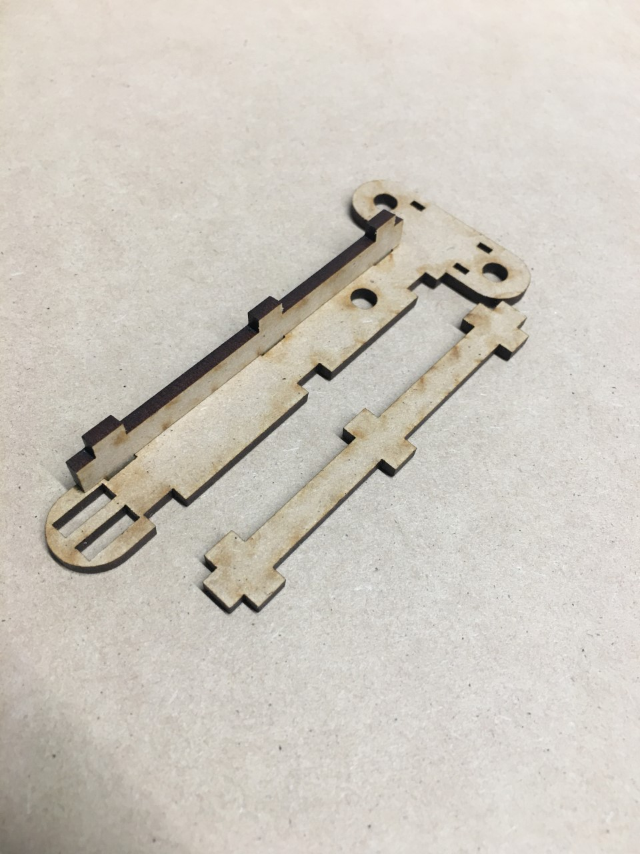

Step 2.
Glue on the two small support pieces as shown in the picture. 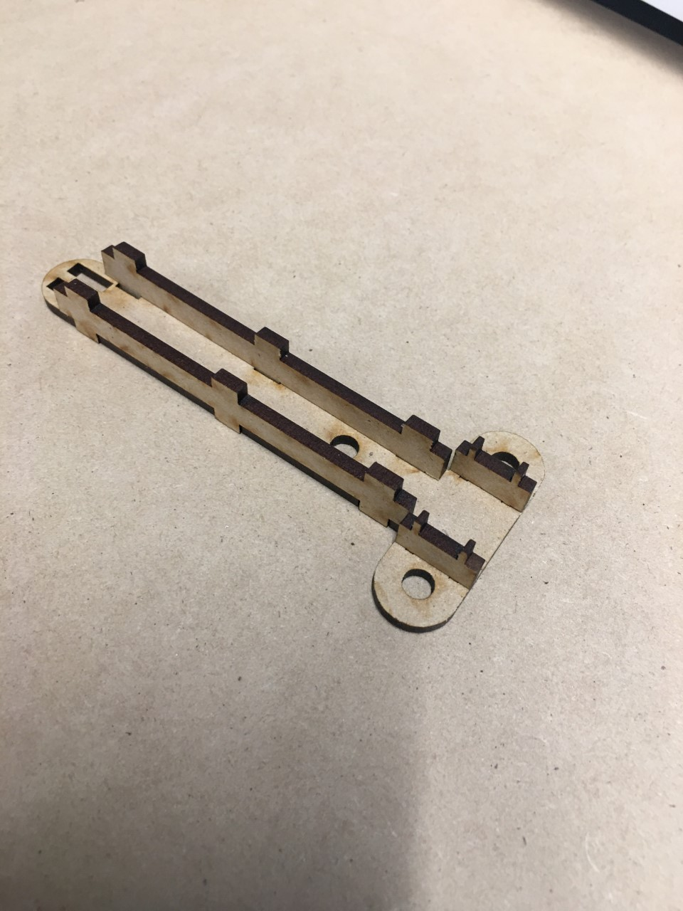

Step 3.
Next glue the bottom portion of the main body onto the rest of the assembly.
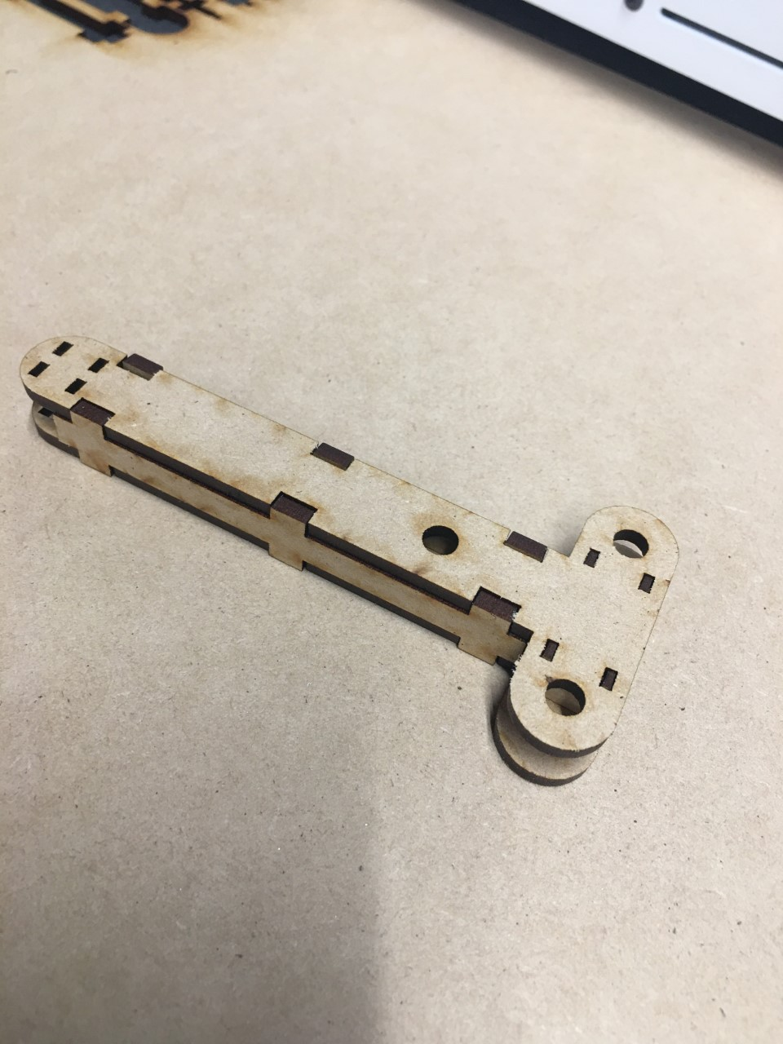

Step 4.
Glue together the handle portion.
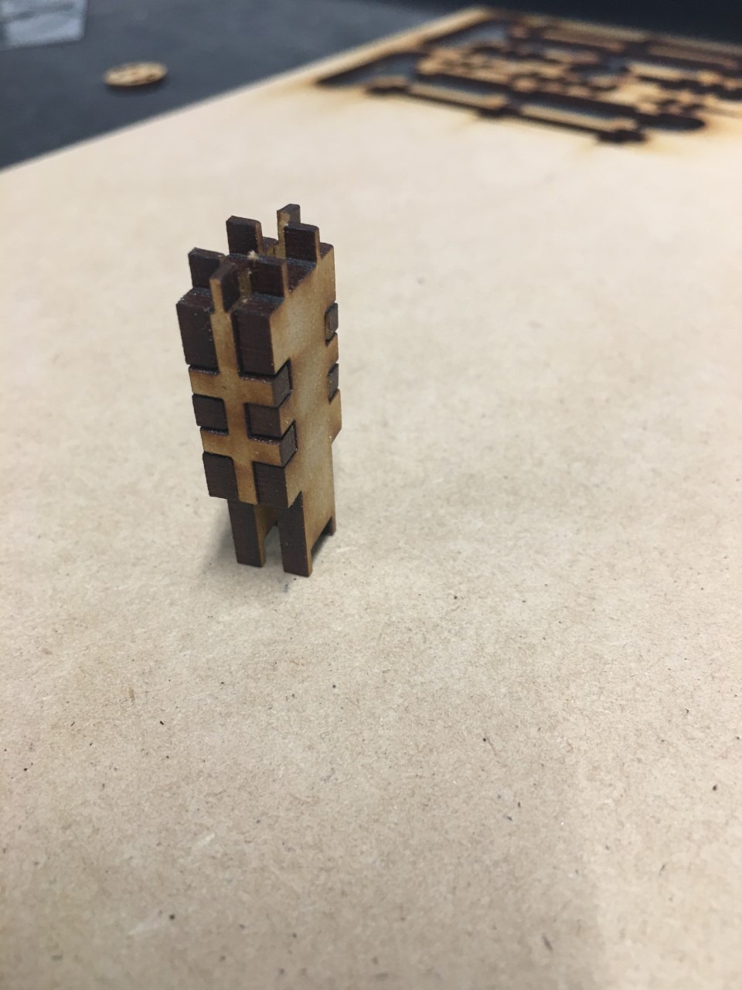

Step 6.
Next, slide the handle assembly down through the main body of the handle. Apply glue on surfaces.
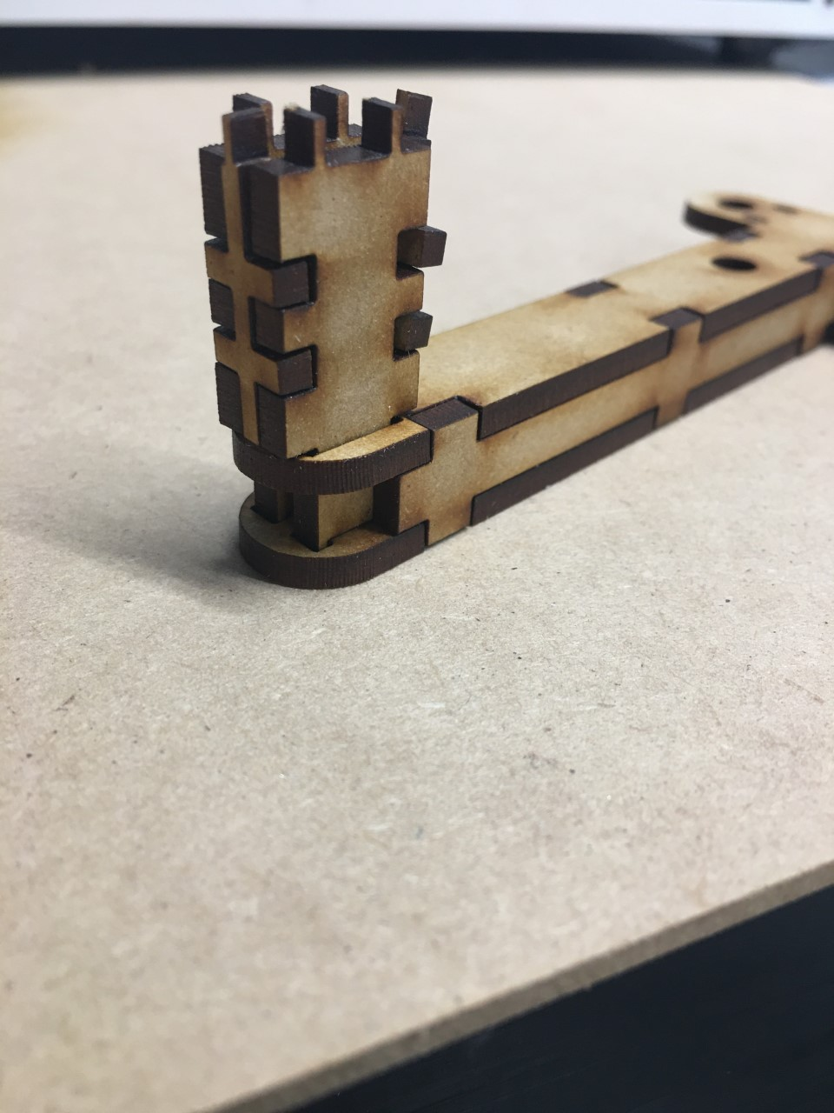

Step 7.
Glue the circular piece onto the top of the handle to hold it all together.
